 Activity 4: Constellation Scrapbook

What are some of the constellations in the night sky?

In this activity you will research various technologies and procedures used to learn about planets and other objects in the night sky.

Resources

Access the following website using this link:

• Constellation Guide (<http://www.constellation-guide.com/>)

Instructions

1. To demonstrate your learning about constellations, construct a scrapbook in which you describe four constellations.

2. Each of the four entries in your constellation scrapbook should include the following:

• Name of constellation

• Number of stars in the constellation

• Special features in the constellation (such as galaxies, nebular, meteor showers, etc.)

• A brief story or myth associated with the constellation

• Picture of the constellation that shows the stars connected

• Picture of the mythological figure for your constellation

3. You may use the *Constellations Guide* website which provides information and images of each of the 88 constellations. Or, you may use other websites.

Note: The twelve zodiac (meaning little animals) constellations are located within a band that is about 20 degrees wide in the sky. This is the path where the Sun, the Moon, and the visible planets move.

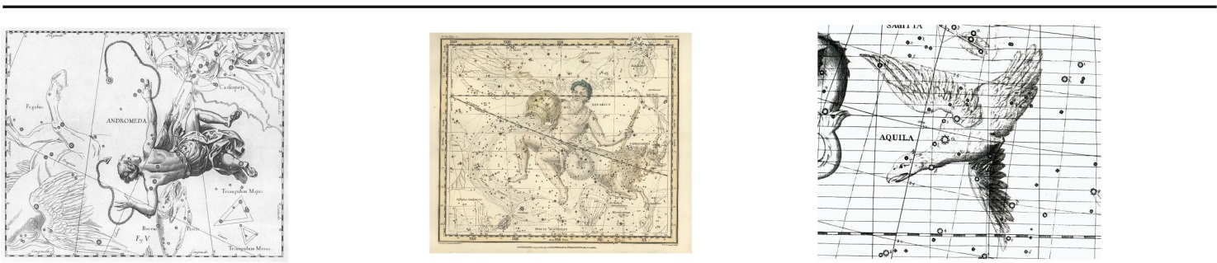Possible Constellation Choices:

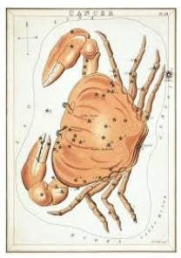Andromeda (the Princess) Aquarius (the Water Bearer)

Aquila (the Eagle)

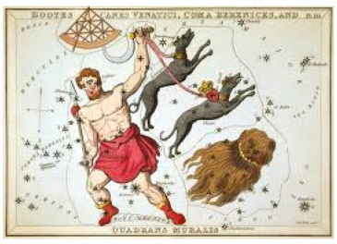

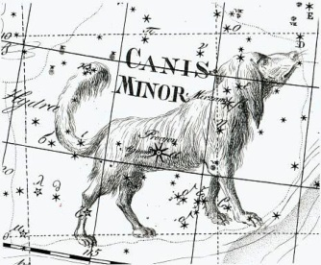Bootes (the Herdsman)

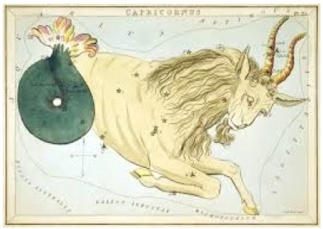

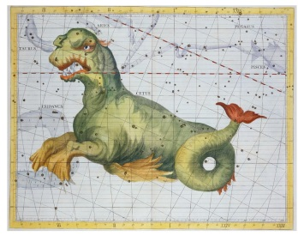Capricornus (the Goat)

Cancer (the Crab)

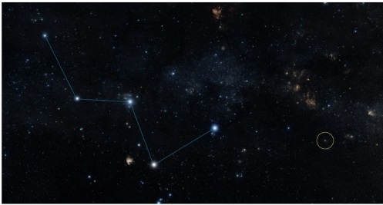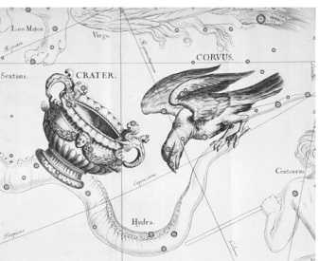Casseopeia (the Queen)

Canis Major/Minor (the Dog)

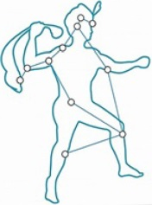

Cepheus (the King)

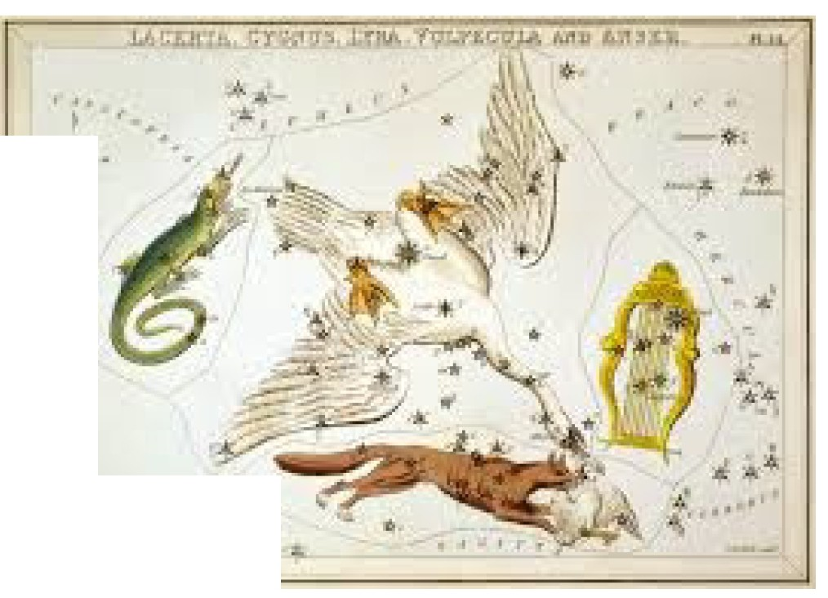

._..

"' . ....

Cetus (the Sea Monster) Crater and Corvus (Cup and Raven Cygnus (the Swan)

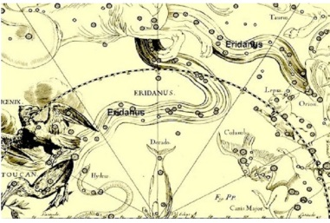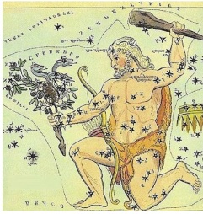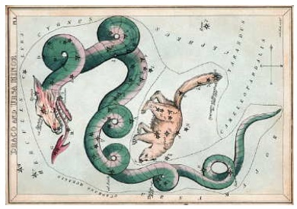

Draco (the Dragon) Eridanus (the River) Hercules (the Strong Man)

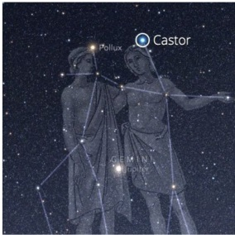Gemini (the Twins)

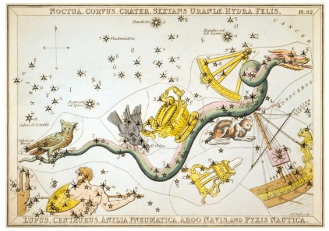Hydra (the Water Serpent)

. - -- -=-=-!!-

Leo (the Lion)

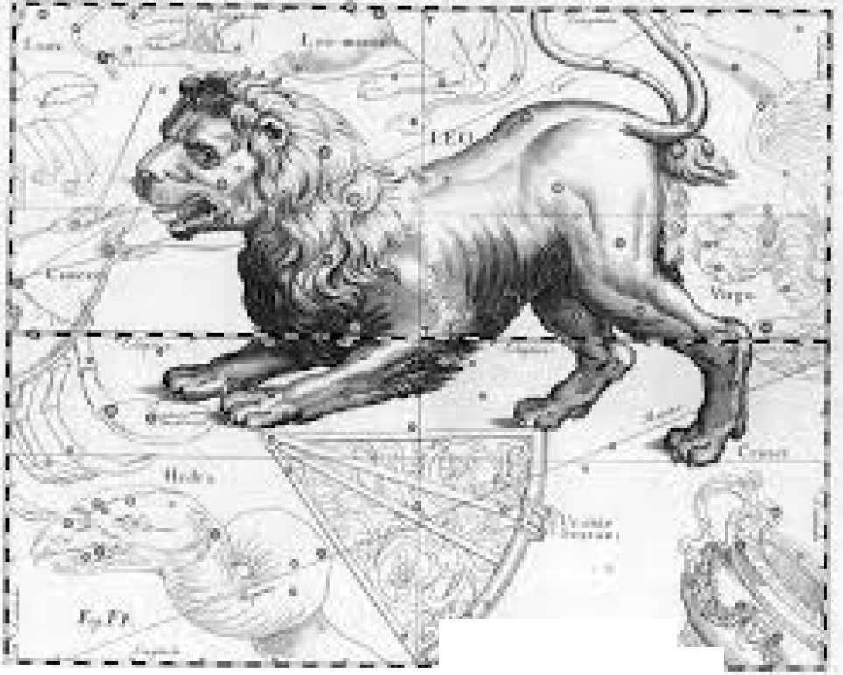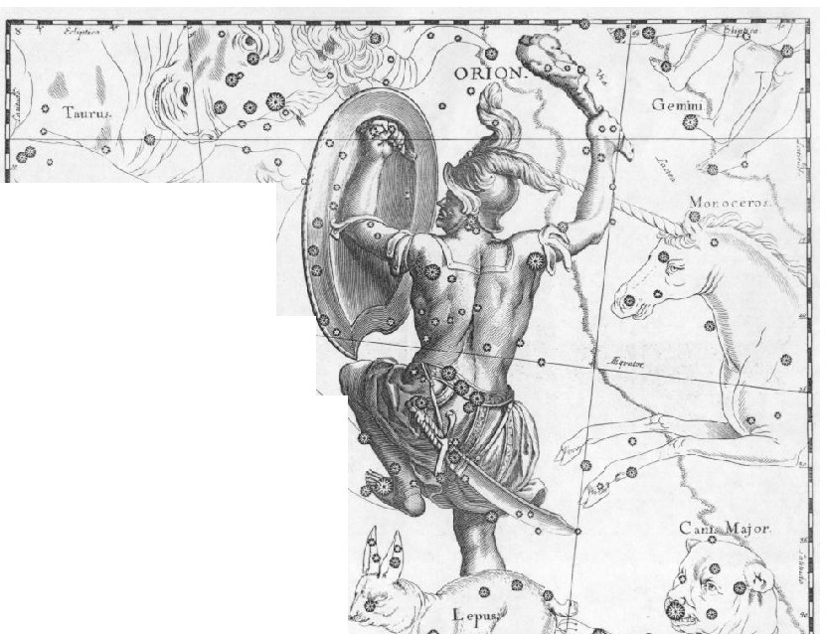

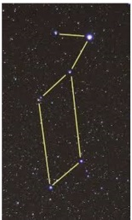l; ··;f·.

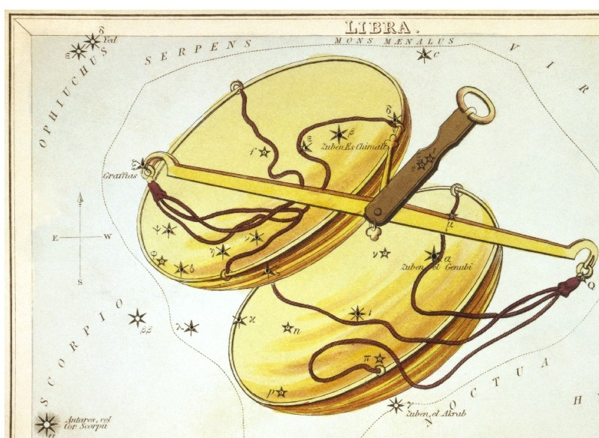

1! · •.. .. . \. ..

,:i • :.

t. h--:.•.- *"·>::•·>,:C:L::•,...._:•.*..!..I

Libra (the Scales)

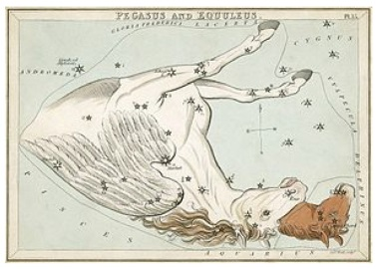

Pegasus (the Winged Horse)

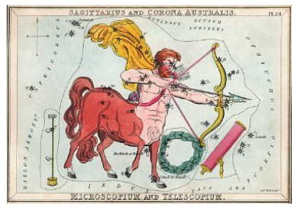

Sagittarius (the Archer)

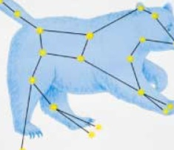

Ursa Major (the Big Bear)

Lyra (the Harp)

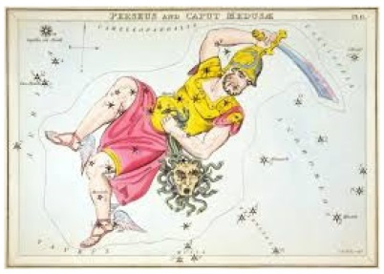

Perseus (the Hero)

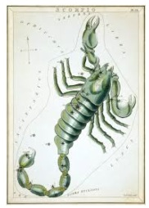

Scorpius (the Scorpion)

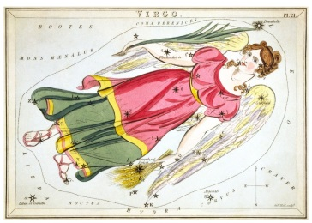

Virgo (the Virgin)

Orion (the Hunter)

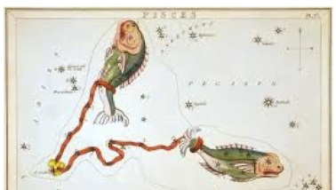 -- -:--

Pisces (the Fish)

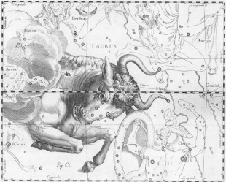

Taurus (the Bull)

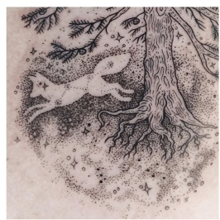

Volpecula (the Fox)

Constellation Scrapbook