 Activity 8: Seasonal Differences

How does the angle of the Sun change with the seasons? Resources

• *Seasons Simulators:* Note, you need flash for the first simulation, but not for the second. <http://astro.unl.edu/classaction/animations/coordsmotion/eclipticsimulator.html>

[https://www.khanacademy.org/science/cosmology-and-astronomy/earth-history­](http://www.khanacademy.org/science/cosmology-and-astronomy/earth-history)

topic/earth-title-topic/p/season-simulator

[https://www.pbslearningmedia.org/resource/npls13.sci.ess.seasons/why­](http://www.pbslearningmedia.org/resource/npls13.sci.ess.seasons/why)

seasons/#.WIQtv9-nFPY

Instructions

1. Open a *Seasons Simulator.*

2. For the flash version, be sure the "labels" box is checked in the bottom right of both screens so you can see where everything is located.

3. For the flash version, find the little stick-person in the top right-hand box. Drag the person so that the "observer's latitude" reads about 55 N (this is approximately where Grande Prairie is located in northern Alberta). For non-flash versions, you may choose New York 41 degrees North, or even the Tropic of Cancer, whichever is the most Northerly location in the simulator.

4. Click on "start animation" in the bottom right-hand corner of the screen to see the Earth move around the Sun.

5. Watch the top right window to see how the hours of daylight change throughout the year. The shaded portion indicates the night and the lighted portion indicates the day.

6. Note the movement of the sun as well as the calendar at the bottom of the screen.

7. Fill in the missing sections on your *Seasonal Changes* Worksheet based on what you observe from the *Seasonal Simulator.* The first one is done for you.

8. You can click on the "stop animation" button at any point to take a closer look and draw your diagrams.

Seasonal Changes Worksheet

The first days of each season changes yearly by a day or two. An approximate date is given to help you draw the proper image.

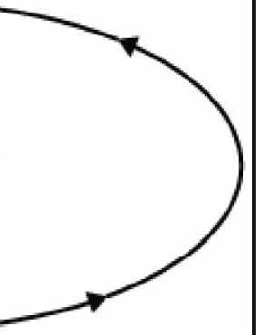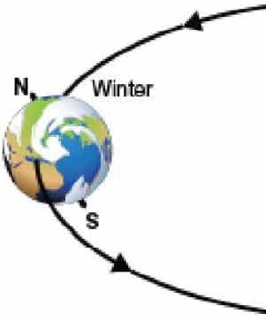

Seasons Earth's Position Around the Sun

(diagram)

Winter

The first day of Winter is approximately

December 20th.

Sun

Spring

The first day of Spring is approximately March 20th.

|  |  |
| --- | --- |
| Seasons | Earth’s Position Around the Sun  (diagram) |
| Summer  The first day of Summer is approximately June 21st. |  |
| Autumn  The first day of Autumn is approximately September 21st. |  |

ADLC Science 6

|  |  |
| --- | --- |
| Question | Observation |
| For what fraction of the day is the person in the light in the winter- more than half, less than half, or about hair? |  |
| For what fraction of the day is the North Pole in the light during June? |  |
| Explain the reason for the temperature difference between Summer and Winter. |  |
| Explain why the days are longer in the Summer than in the Winter if Earth takes the same amount of time to complete its daily rotation. |  |