Unit 1 Name:

Date:

1-1: Make and Use a Sundial

Discover: Making and Using a Sundial

**Question**

How can a simple sundial track the time of day?

In this activity, you will build your own simple **sundial**.

**Materials**

● a sunny day

● pencil

● print-out of the Sun Clock diagram below

● clock or watch

**Instructions**

|  |  |  |
| --- | --- | --- |
| **1** | Pri | nt a copy of the **Sun Clock Diagram on page 2 below**. |
| **2** | Yo | u must locate geographic north before you can use your **Sun Clock Diagram**. |
|  | ● | Go out the night before you do this activity and look for the **North Star**. (You learned how to do this earlier in the unit.) |
|  | ● | Mark an arrow on the ground that points toward the **North Star**. That's geographic **North**. If you cannot go out the night before, ask a parent to help you find which way is **North**. |

**3** On the next day that is sunny, position your **Sundial Diagram** with the geographic north arrow (in the top right-hand corner of the diagram) pointing in the same direction that you marked on the ground (toward geographic north).

**4** Make sure the paper cannot move by placing a couple of rocks to weigh it down if there is a breeze.

**5** Choose three hours in the day (one hour in the morning, one in the afternoon, and one in the evening). At the top of the hour (10:00 for example) stand a pencil upright. Make sure it is perpendicular to the ground using a plumb bob (a piece of string with a weight on it).

Place the pencil on the line in the middle of the **Sundial Diagram** on today's date. For example, if you are doing this activity on April 1, put the pencil at that point on the line. Look where the pencil shadow is - that is the time of day according to the **Sundial Diagram**. Record your observation in the **Sundial Sketch Chart** provided at the end of this document. In addition, record in the chart the actual time of day using a watch or clock.

**6** Leave your sun clock in that location, or if you must take it inside, return it to the exact spot when you use it again.

**7** Choose one hour in the morning, one in the afternoon, and one in the evening during which to record your observations.

**8** For the next two days, use the same times of day to take three measurements or observations each day.

For every degree you live away from your local meridian, the time will vary. For every degree east, add four minutes; for every degree west, subtract four minutes. A degree in latitude is about 100 kilometers, which will help you to take this difference into account.

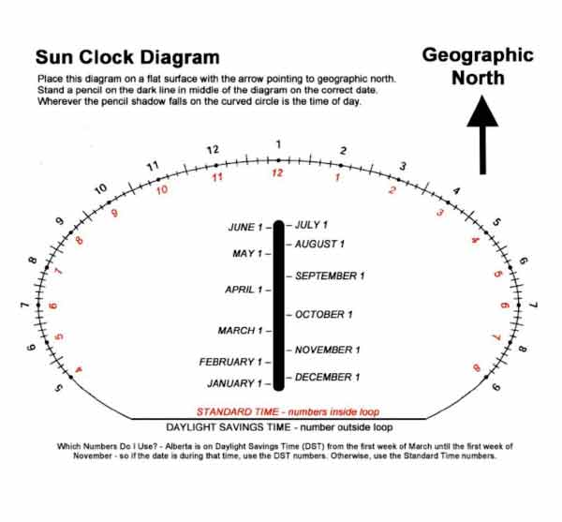

**Sundial Observation Chart**

Complete the Chart below.

|  |  |  |  |
| --- | --- | --- | --- |
| Time of Day (Using a clock or watch)  (Choose one consistent time in the morning, one consistent time in the afternoon, and one consistent time in the evening.) | Photo of Sundial (Where the Shadow Fell on the Clock) | Photo of Sundial (Where the Shadow Fell on the Clock) | Photo of Sundial (Where the Shadow Fell on the Clock) |
|  | Day 1 | Day 2 | Day 3 |
|  |  |  |  |
|  |  |  |  |
|  |  |  |  |

( /9 marks)

**Additional Observations**

1. Does the Sun emit or reflect light? ( /1 mark)

|  |
| --- |
|  |

1. Identify one method you can use to view the Sun safely? ( /1 mark)

|  |
| --- |
|  |

1. Measure the length of the shadow (the distance from your pencil to the end of the its shadow**) on the three readings you make one day**. Write the measurements below. (/3 marks)

|  |
| --- |
|  |

1. What time is the shortest shadow during the day? This is solar noon. (/1 mark)

|  |
| --- |
|  |

1. What is the path of the sun as it moves across the sky? (/2 marks)

|  |
| --- |
|  |

1. Predict. Will the path of the sun across the sky and the pattern of the shadows on the clock change during the year? Explain your prediction. (/2 marks)

|  |
| --- |
|  |

1. Ashley wanted to investigate the movement of the Sun over the course of a day.

She used a sundial to measure the length of a shadow once every hour from

sunrise to sunset. (/3 marks)

1. **Identify two variables must be kept the same (controlled variable) in order to obtain reliable data from this activity?**
2. **Identify one variable that changes (independent variable) in this experiment**

|  |
| --- |
|  |

Total: /22 marks