

Exit Pass Lesson 1

**Gases In Our Atmosphere.**

Complete the following.

**Instructions**

**1** Complete the circle graph on the following page with the gases that make up our atmosphere.

**2** In each section, place the name of the correct gas plus one FACT you learned about this gas

(such as what does it do, or where does it come from, or how is it used?)

**Gases in Our Atmosphere**

**Name of gas:**

**Gas FACT:**

**Name of gas:**

**Gas FACT:**

**Name of gas:**

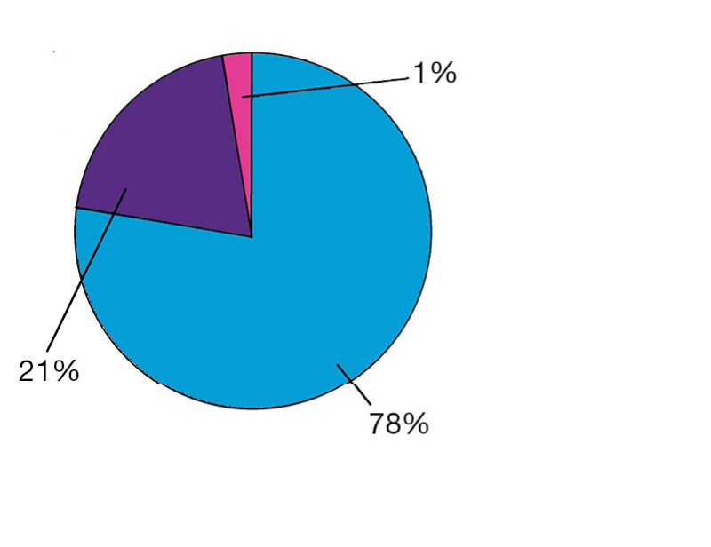

**Gas FACT:**