 Activity 5: Is Air Really There?

(Note this activity can be used with Assessment 2-1)

How can we show that air

● takes up space (volume)?

● has mass (weight)?

● exerts pressure?

● can be compressed?

**Resources**

● balloons

● ruler or long stick or dowel

● string

● tape

● paper

● pin

● tissue paper

● ping-pong ball

● pot

● plastic or glass cup

● PhET simulation

**Hypothesis**

Read each activity in the "Procedure" and predict what you think might happen.

**Activity Hypothesis**

**Paper Chase**

**Need a Hint?**

Which piece of paper will fall faster?

**Balloon Balance**

**Need a Hint?**

What will happen to the other balloon when you pop one?

**Air Underwater**

**Need a Hint?**

What will happen to the ping-ping ball and the paper when you put the cup into the water?

Skill Builder

How to write a hypothesis.

If you need to use this Skill Builder, access it from the online course.

**Procedure**

**1** Perform each activity described.

**2** After each activity, record what happened, and try to explain how the air caused the result you observed.

**3** For those activities you are unable to do, click the videos to watch what happens.

**Activity 1: Paper Chase**

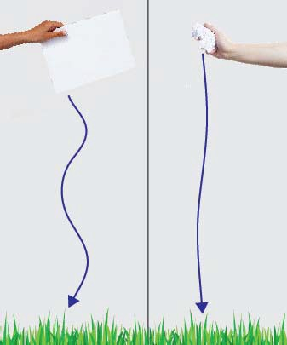**1** Take one flat sheet of paper and one crumpled up sheet of paper. Hold them both in the air.

**2** Drop both pieces of paper at the same time from the same height.

**Activity 2: Balloon Balance**

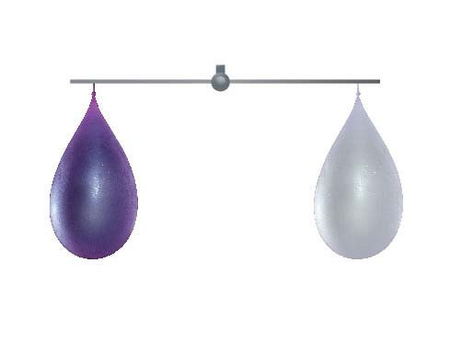**1** Blow up two balloons to approximately the same size.

**2** Tape each balloon to opposite sides of a ruler or another long stick.

**3** Tie a string to the middle of your ruler so that the balloons are balanced on either end.

**4** Now, take a pin and carefully pop one of the balloons.

**Activity 3: Air Under Water**

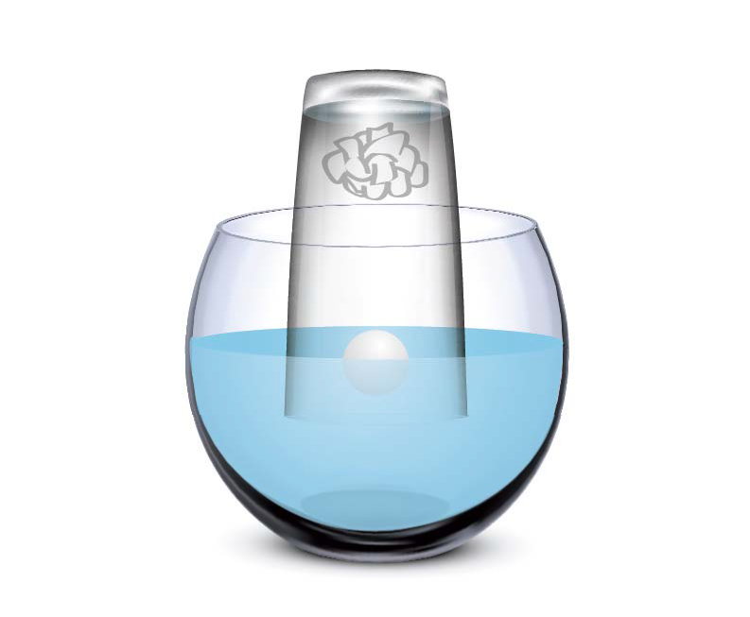**1** Fill a bowl about halfway with water. Place a ping-pong ball in the water.

**2** Crumple a piece of tissue paper, and push it into the bottom of a cup.

**3** Place the cup upside down over the ping- pong ball in the pot of water.

**4** Notice what happens to the ping-pong ball.

**5** Remove the cup, and notice what happened to the tissue paper.

**Activity 4: PhET Simulation**

**5** Go to the **Gas Properties PhET** website and click **Run Now**.

**6** Click the handle to pump some gas particles into the container.

**7** Click and drag the left side of the container to the right to make the container smaller.

**8** Click and drag to make the container larger.

**9** Record your observations in the **Observations Table**.

**Observations Table**

**Activity What Happened? Can you explain what happened?**

**How was AIR involved?**

Paper Chase **Need a Hint?** Which piece of paper fell faster?

**Need a Hint?** Why did the flat sheet of paper fall slower? (Think about air pushing against it as it fell.)

Balloon Balance **Need a Hint?** What happened to the other balloon when you popped one?

**Need a Hint?** Does air weigh anything? How do you know?

Air Underwater **Need a Hint?** What will happen to the ping-pong ball and the paper when you put the cup into the water?

**Need a Hint?** Why did the ping-pong ball get pushed down? Why did the paper stay dry? Level 2: What was inside the cup that kept the paper dry and pushed the ball down?

|  |  |
| --- | --- |
| PhET Simulation Questions | Observations |
| 3 a. What do the gas particles do when you pump them into the container?  **Need a Hint?** Did they move around or stay still? |  |
| 4 a. What happens when you make the container **smaller**?  **Need a Hint?** What did the gas particles do? |  |
| 4 b. What happens when you make the container **bigger**?  **Need a Hint?** What did the gas particles do? |  |

**Conclusion**

Using the observations you made during the activities, answer the questions you set out to explore:

**1.** How can we show that air:

**a.** takes up space?

|  |
| --- |
|  |

**b.** exerts pressure?

|  |
| --- |
|  |

**c.** can be compressed?

|  |
| --- |
|  |

**d.** has mass (weight)?

|  |
| --- |
|  |

**2** Air has weight and presses against everything it touches. This is called air

.

pressure, spread, compressed, poured, around

**3** Air can be to fit into a smaller container.

pressure, spread, compressed, poured, around

**4** Air can be to fit into a larger container.

pressure, spread, compressed, poured, around