 Activity 7: Forces of Flight

**Question**

What are the forces of flight?

**Resources**

Access the website link from the online course or click on the link below.

● [How Do Things Fly](http://howthingsfly.si.edu/)

**Instructions**

**1** Go to the **How Do Things Fly** website. Watch the short video clip on forces of flight.

**2** After you have watched the video, click the button that says **Learn More about the Forces of**

**Flight**, and read this selection carefully.

**3** Next, click the box that says **The Four Force**s. Read this selection and use this information to complete the questions below.

**Questions**

**1** In the blue outlined box of each arrow, label each force of flight acting on the airplane.

**2** In each arrow explain how each force is involved in flying.

Label

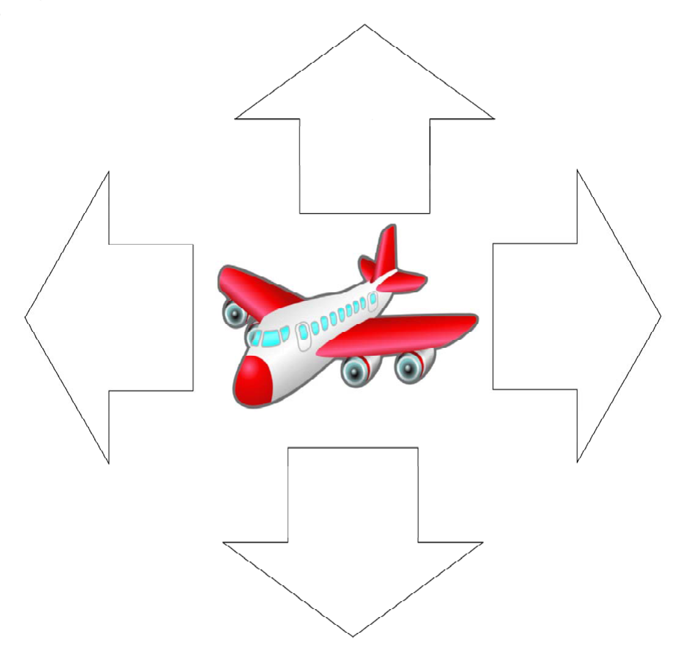

Label

Label

Label