 Activity 11: Bernoulli Brainteaser

**Question**

How can we show Bernoulli’s Principle at work?

**Resources**

● sheets of paper

● ping-pong ball

● hair dryer

● scissors

**Hypothesis**

Read each of the activities in the "Procedure", and predict what you think might happen.

**Activity Hypothesis**

**Blowing on Paper**

**Need a Hint?**

Will the paper move up, down, or stay unchanged?

**Paper Strips**

**Need a Hint?**

Will the strips of paper move together or apart?

**Ball Balancer**

**Need a Hint?**

What will happen to the ping-pong ball?

**Procedure**

**1.** Perform each activity described.

**2.** After each activity, record what happened.

**3.** For those activities you are unable to do, click the videos to watch what happens.

**Activity 1: Blowing on Paper - video**

Access the link to the video from the online course, or click [here](https://www.youtube.com/watch?v=MYXiL2wGDAw).

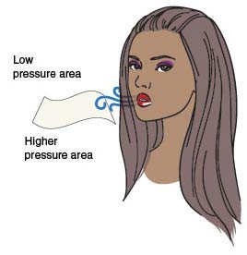**1.** Take one flat sheet of paper and hold it immediately beneath your bottom lip with your thumb and forefinger.

**2.** Take a deep breath and blow directly over top of the paper.

**Activity 2: Paper Strips - video**

Access the link to the video from the online course, or click [here](https://www.youtube.com/watch?v=875OxBxGDFg).

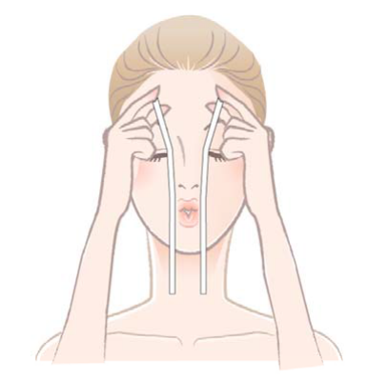**1.** Cut a piece of paper in half length-wise.

**2.** Hold the two pieces of paper side by side in front of your face. (The flat surfaces of the paper are facing each other.)

**3.** Blow between the two sheets of paper.

**Activity 3: Ball Balancer - video**

Access the link to the video from the online course, or click [here](https://www.youtube.com/watch?v=5zD7Le2mGFg).

**Safety Warning: Be careful as you do this activity. Be sure the hair dryer is set on 'cool air'.**

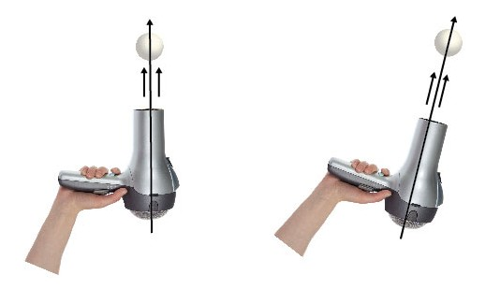**1** Turn on your hair dryer and point it upwards.

**2** Place the ping-pong ball in the air stream of the hair dryer.

**3** Try tilting the hairdryer to see what happens.

**Observations Table**

**Activity What Happened?**

**Blowing on Paper Need a Hint?**

Did the sheet of paper move up or down?

**Paper Strips Need a Hint?**

Did the paper strips move together or apart?

**Ball Balancer Need a Hint?**

What happened to the ping pong ball?

**Conclusion**

Go back to your hypothesis for each activity and indicate if your hypothesis was correct or incorrect. Then, try to explain what happened using Bernoulli's Principle.

**Activity Hypothesis correct/incorrect?**

**Can you explain what happened using**

**Bernoulli's Principle?**

**Blowing on Paper Need a Hint?**

The air flowing over the paper was moving faster and with lower pressure.

**Paper Strips Need a Hint?**

The air flowing between the sheets of paper was moving faster and with lower pressure.

**Ball Balancer Need a Hint?**

The air flowing past the ping-pong ball was moving faster and with lower pressure.