

Exit Pass Lesson 4

**Bernoulli’s Principle**

Complete the following.

**Instructions**

1. Use the picture to answer the questions.

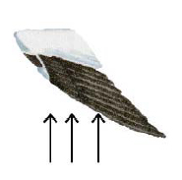

**Questions**

1. Explain how the shape of a bird's wing is adapted to produce lift. Be sure to include the following in your answer:

* an explanation of how Bernoulli's Principle works
* how the air flows over the wing
* how the regions of low and high pressure create lift?

|  |
| --- |
|  |