 Activity 12: What is Drag?

**Question**

What factors affect drag?

**Resources**

● sink or bathtub full of water  your hand

**Hypothesis**

Think of all the times you have gone swimming or played in the bathtub. Based on those experiences, construct a hypothesis by selecting the word to complete the following statement:

**1.** An object moving through a denser (thicker/heavier) fluid experiences ***more*** or ***less*** drag.

Hypothesis:

**2.** A faster moving object experiences ***more*** or ***less*** drag.

Hypothesis:

**3.** A narrower, smoother object experiences ***more*** or ***less*** drag.

Hypothesis:

**Procedure**

**Part A**

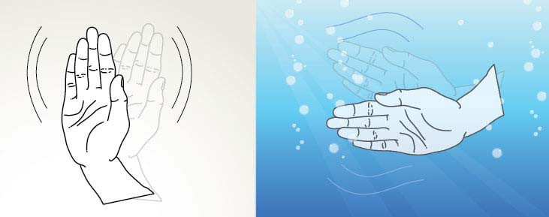**1** Fill a bathtub or sink full of water.

**2** Wave your hand through the air. Then, wave your hand through the water.

**3** Which fluid did you notice produce more drag? Record your observations in the **Observations Table**.

**Part B**

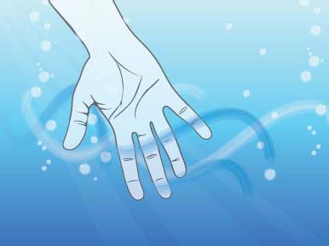**1** Move your hand through the water slowly.

**2** Move your hand through the water faster.

**3** How does the drag change as you move your hand faster. Record your observations in the **Observations Table**.

**Part C**

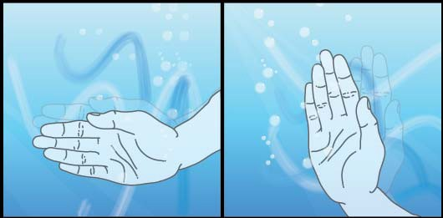**1** Slide your hand sideways through the water.

**2** Then, try moving your hand palm flat facing directly into the water.

**3** Which way produced more drag? Record your observations in the **Observations Table**.

**Observations**

**Part Question Observations**

**A** Which produced more drag, the air or the water?

**B** How does the drag change as you move your hand faster?

**C** How does the drag change as you change the shape of your hand?

**Conclusion**

Re-visit your hypothesis to see if you were correct. If you need to, make changes in the statements in your conclusion to reflect what you observed in this activity.

**1.** An object moving through a denser (thicker/heavier) fluid experiences ***more*** or ***less*** drag.

Conclusion:

**2.** A faster moving object experiences ***more*** or ***less*** drag.

Conclusion:

**3.** A narrower, smoother object experiences ***more*** or ***less*** drag.

Conclusion: