

Exit Pass Lesson 5

**Drag**

Complete the following.

For each of the following pictures, explain why drag should be increased or decreased and how this is accomplished in the example below.

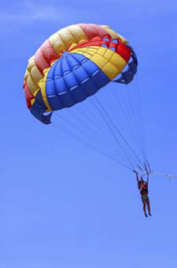

**1.**

|  |
| --- |
|  |

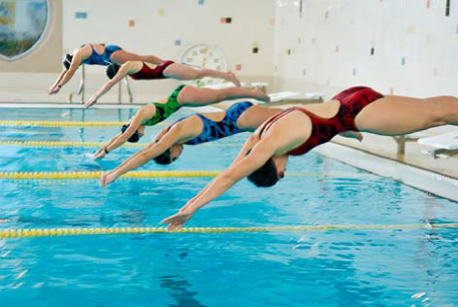

**2.**

|  |
| --- |
|  |