 Activity 16: Propulsion Pop

**Question**

What fuel provides the best propulsion for a rocket?

**Resources**

● *Rocket Design Worksheet*

● film canister (The small containers with the lids that click inside the canister work best. (You might get empty ones free from photography stores.)

● paper

● garbage bags or newspaper

● eye protection

● Alka-Seltzer tablets

● water

● tape

● markers

**Hypothesis**

Select from the following answers and fill in the blanks: one full, one half, one quarter. I think the rocket will fly the highest with tablet of Alka-Seltzer and

canister of water.

**Instructions**

**1.** Begin designing your rocket:

● Use the **Planning and Design** portion of the **Rocket Design Worksheet** to guide your planning.

● Be sure you consider all parts of your design and be sure you have access to the materials you will need.

● Save the **Rocket Design** to your computer.

● Start building your rocket. Write any questions you might have for your teacher if you have any problems with your rocket.

● Do **not** test your rocket until you have met with your teacher.

**2.** Be sure to have explained what method of propulsion your rocket will use and other parts of the design you have included.

**3.** Prepare to launch your rocket. Be sure you have adult permission and supervision for your launch.

**4.** Be prepared for problems! You may need more fuel or materials for repair at the test site.

**5.** Launching outside is preferable (weather permitting). Be sure you are in an open space with nothing directly over head.

**6.** You will need to lay down newspapers or garbage bags over your launch site to make clean-up easier.

**7.** Place your chosen fuel quickly into your rocket, place it on the launch pad, and move quickly out of the way.

**8.** Record how your rocket flew.

**9.** Repeat Steps 7 and 8 two more times.

**Rocket Design Worksheet**

**Planning and Design**

**1 Method of Propulsion** - This is your manipulated variable.

● The reaction of Alka-Seltzer with water produces carbon dioxide gas. The pressure from this gas will cause the film canister cap to pop off and launch your rocket.

● You must decide how much Alka-Seltzer and water to use for each trial to determine which combination gives you the best propulsion (resulting in the rocket going high). **One** of your test launches should be for the amount you predicted in your hypothesis.

● When you are ready for action, fill the film canister with water, place the Alka-Seltzer tablet in it, and **quickly** place the cap on.

**\*\*Be sure to follow proper launch protocol when doing trials! Have adult permission and supervision, and perform the test outside, if possible.\*\***

**2 Rocket Size and Shape**

● Next, you must decide how your rocket will look. You can use paper, tape, and markers to decorate your rocket and make it look unique.

● You may want to consider adding a nose cone and fins to your rocket.

● Use the diagram on the following page as a guide for how to design your rocket.

Rocket Design Diagram

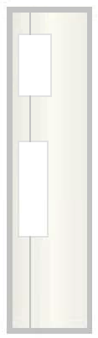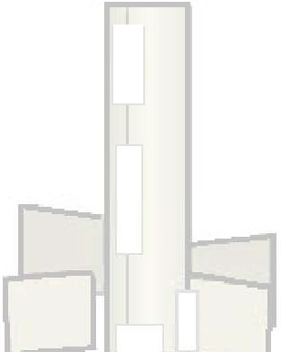1 *2* 3

Paper can be wrapped around the canister to form the body of the rocket. You decide how long you want

your rocket to be!

Lid

Decide if you want fins for your rocket. How many? What size or shape?

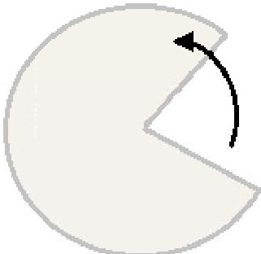

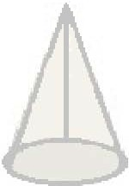You can add a nose cone if you wish.

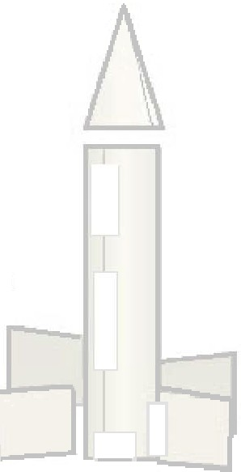

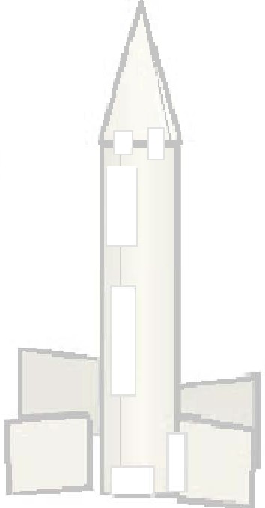Are you ready for launch?

Realize that anything you add to your rocket will make it **heavier.** If you have more **weight** on your rocket, you will need more **thrust** to launch it.

**Diagram**

My rocket will look like this. Be sure to label all the parts.

|  |
| --- |
|  |

**Method of Propulsion**

**The method of propulsion I will be using for my rocket will be... (Be sure to include the amount of each you plan to use.)**

**Launch #1:**

- amount of Alka-Seltzer:

- amount of water:

**Launch #2:**

- amount of Alka-Seltzer:

- amount of water:

**Launch #3:**

- amount of Alka-Seltzer:

- amount of water:

**Observations**

**Rocket Testing**

**Launch # Fuel Used How did the rocket fly?**

**Amount of**

**Alka-Seltzer**

**Amount of Water**

**Need a Hint?**

Did the rocket go high or low? Did it tip over? Did it go straight or off to one side? Did parts of the rocket fall off? Did you have problems with the fuel?

**1**

**2**

**3**

**Conclusion**

Which fuel combination provided you with the best propulsion?

|  |
| --- |
|  |