Unit 2 Name:

Date:

2-2: Design an Aircraft

Discover: Forces in Flight

Question

What are the forces of flight?

Instructions

Pretend you are the designer of an aircraft. You are trying to sell your design to a potential buyer. The buyer wants to be sure the aircraft will fly properly. You will need to explain the various forces of flight to your buyer. Show how your aircraft has a superior flying ability. You can choose to

* construct a pamphlet

or

* construct a PowerPoint using relevant images or diagrams

Choose one of the following aircrafts shown in the pictures below (or provide your own photo).

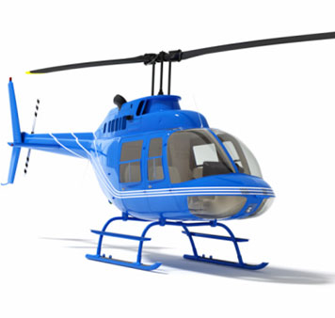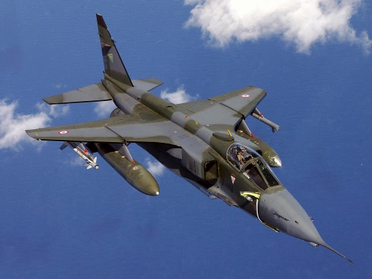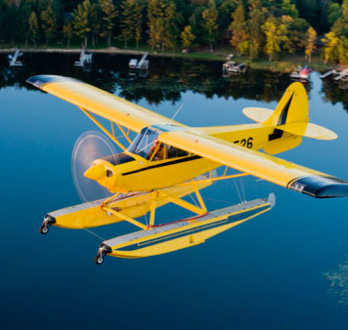

Your "Forces in Flight" sales pitch should include the following:

* an explanation of how Newton’s law is used by your aircraft
* a diagram of the various forces acting on the aircraft (lift, weight, drag, and thrust)
* an explanation of how the aircraft overcomes drag (how shape and size affects air resistance)
* an explanation of what Bernoulli's Principle is and how it is acting on your aircraft
* an explanation of the kind of propulsion used by your aircraft and how it increases thrust
* pictures and diagrams to accompany your explanations

**Forces in Flight Rubric**

|  |  |  |  |  |
| --- | --- | --- | --- | --- |
|  | **Excellent**  **5** | **Proficient**  **4** | **Satisfactory**  **3** | **Limited**  **2** |
| Content/15 | * I provided *comprehensive* and *engaging* explanations of the forces involved in aircraft flight such as Bournoulli’s principle, lift, thrust, and gravity. * I showed various means of propulsion *accurately*. * I identified *insightful* means of reducing drag such as streamlining. | * I provided *thoughtful* and *logical* explanations of the forces involved in aircraft flight such as Bournoulli’s principle, lift, thrust, and gravity. * I showed various means of propulsion *logically.* * I identified *logical* means of reducing drag such as streamlining. | * I provided *clear* and *adequate* explanations of the forces involved in aircraft flight such as Bournoulli’s principle, lift, thrust, and gravity. * I showed various means of propulsion *generally*. * I identified *general* means of reducing drag such as streamlining. | * I provided *inaccurate* and *vague* explanations of the forces involved in aircraft flight such as Bournoulli’s principle, lift, thrust, and gravity. * I showed various means of propulsion *inccurately*. * I identified *inaccurate or vague* means of reducing drag such as streamlining. |
| Presentation  /5 | * I expressed and organized my presentation in an *engaging* and *accurate* way. | * I expressed and organized my presentation in a *logical* and *mostly accurate* way. | * I expressed and organized my presentation in an *adequate* and *somewhat accurate* way. | * I expressed and organized my presentation in a *confusing* and/or *inaccurate* way. |

Total: /20 marks

Save Your File

Save your Table to your Air Notebook folder. Name your file with your name (jsmith) in this format: (yournamehere)sc6-2-2-air. Submit your completed assessment to the submission folder.