

Exit Pass Lesson 7

**Hot Air Balloon**

Complete the following.

**1.** Explain one way to make the hot air balloon rise higher.

|  |
| --- |
|  |

**2.** Explain one way to make the hot air balloon change direction.

|  |
| --- |
|  |

**3.** Label the names of the forces shown acting on the hot air balloon on the diagram on the following page.

|  |
| --- |
|  |

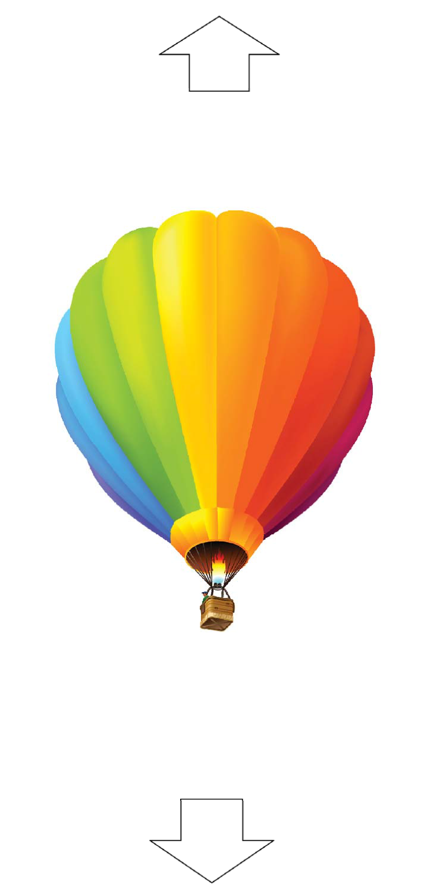

Label Force

Label Force