

Exit Pass Lesson 8

**Bird**

Complete the following. Explain how a bird uses the four forces to fly. Provide one example for each force shown in the diagram below.

Lift

Thrust

Drag

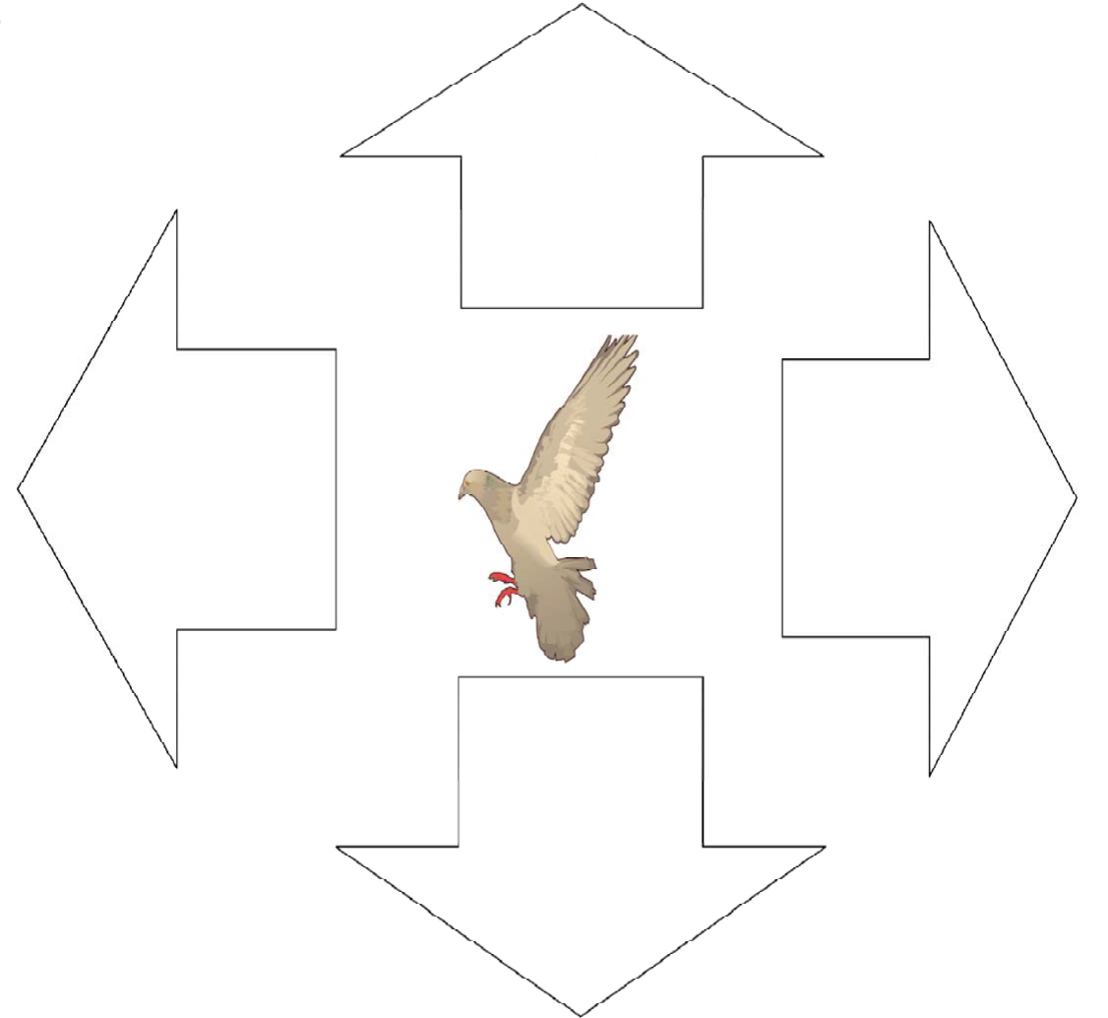

Gravity