**Unit 3 Notebook: Evidence and Investigation**

**Pre-Assessment Unit 3: Evidence and Investigation**

@

What do I already know about evidence and investigation?

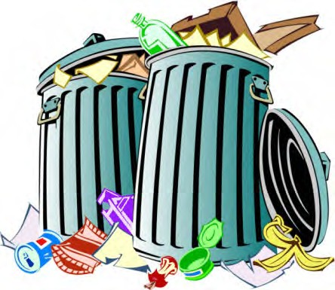**Initial Scenario**

You took out the garbage last night as you always do as part of your chores. However, this morning you noticed this scene in your back alley. Now, you have to clean up the mess that has been left behind.

You would like to find out what happened so you can prevent it from happening again. Start by answering the following questions.

1. What are some observations you might be able to make? This is not limited to what you

see in the picture. Imagine if this were actually your back alley. What kinds of evidence might you gather?

1. What are some inferences you might make about what might have happened to the garbage?
2. What kinds of evidence might suggest your theory is correct?
3. What other information do you think might be useful to find out what happened?

2 **ADLC Science 6**