Exit Pass: Lesson 1



What evidence can be found of human or animal activity? Complete the following.

Questions

Study the two pictures shown below. Complete the charts describing how these two areas might look after the people or animals have left. Be sure to include three or more pieces of evidence for EACH picture to suggest there has been human or animal activity in that area.

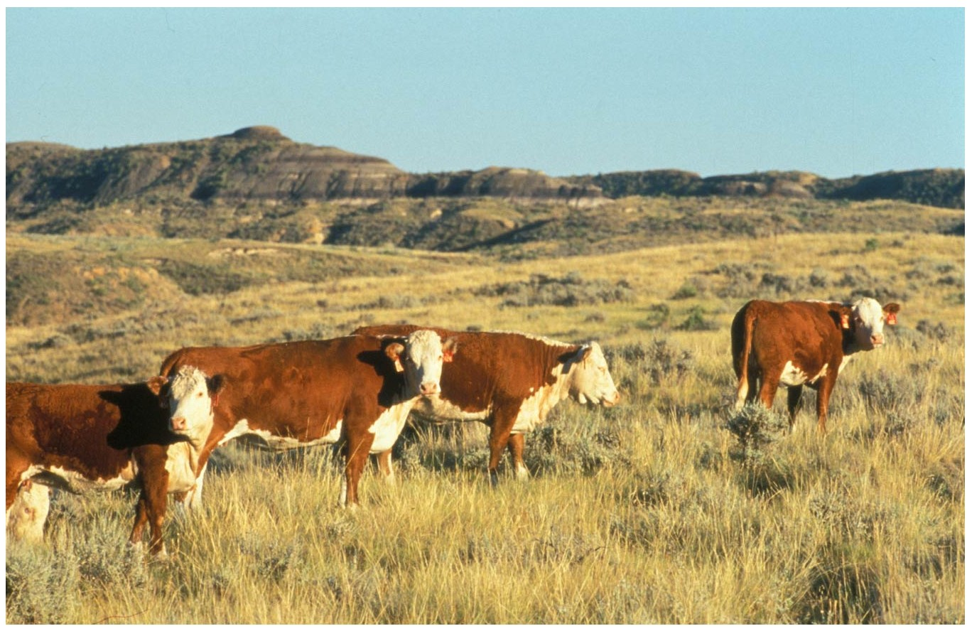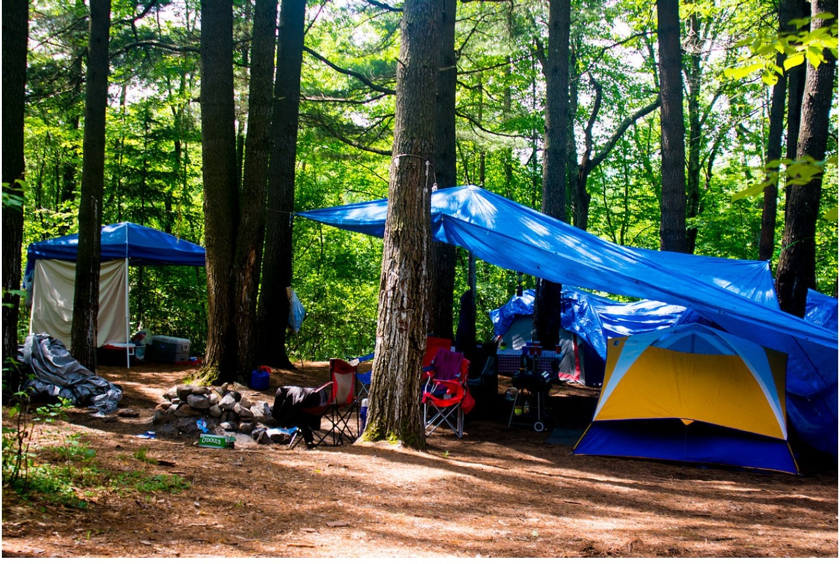

|  |  |
| --- | --- |
| Human Activity | Might Leave Behind… |
| Camping Chairs and Tent |  |
| Tarp |  |
| BBQ |  |
| Campfire |  |
| Picnic Baskets |  |
| People eating food |  |
| People walking around |  |

|  |  |
| --- | --- |
| Ammal Activity | Might Leave Behind… |
| Cows eating |  |
| Cows rolling around |  |
| Cows eating grass |  |