Exit Pass: Lesson 2



How can evidence be used to make inferences? Complete the following.

Questions

Examine the picture. Based on what you see in the picture, fill in the Graphic

Organizer with one inference and three observations that support your inference.

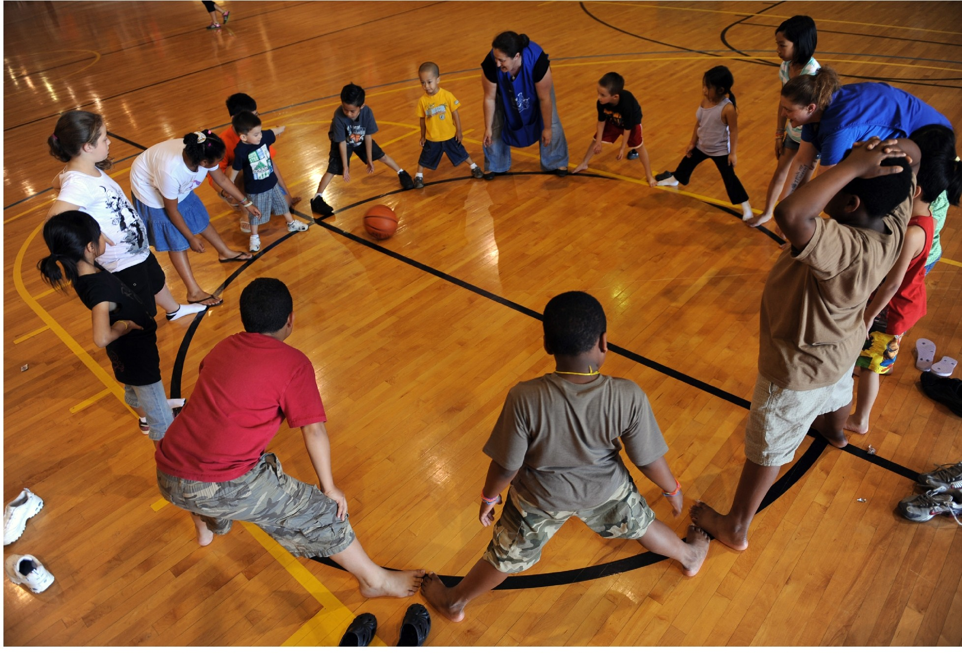

|  |  |  |  |
| --- | --- | --- | --- |
| Inference | Observation 1 | Observation 2 | Observation 3 |
|  |  |  |  |

ADLC Science 6