 Activity 9: Dinosaur Speedway

Can you determine how fast a dinosaur was moving by looking at its footprints? **Materials**

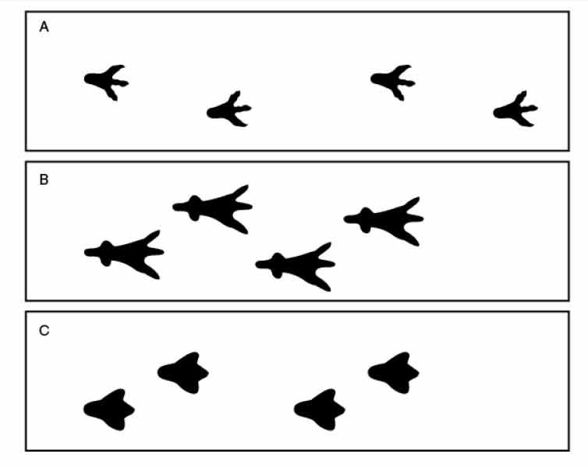

**Instructions**

1. If possible work with a partner. Try walking, trotting, and then running, then, ask a friend to walk, trot, and run while you watch. If you are working alone, watch the video showing a horse as it walks, trots, and runs. [https://www.youtube.com/watch?v=N6wWiatT4xg](http://www.youtube.com/watch?v=N6wWiatT4xg)

When was stride length the longest? Answer: Running- feet move farthest when running. When was stride length the shortest? Answer: Walking - feet stay closest together when walking.

2. Now, look at the dinosaur footprints above.

3. Record your observations on the Dinosaur Footprint Table.

4. Infer which dinosaur you think was walking, trotting, or running.

**Need a Hint?**

A longer stride suggests the dinosaur was moving faster.

|  |  |  |
| --- | --- | --- |
| Dinosaur Footprint Table | | |
| Stride Length | Dinosaur | Walking,Trotting, or  Running? |
| Longest |  |  |
| Intermediate |  |  |
| Shortest |  |  |