Activity 10: Tire Track Challenge

*Can you identify a vehicle from its tire tracks?* **Materials**

• blank paper

• eight Matchbox or Hot Wheels cars

• ink pad

• ruler

• paper towels

**Parent Instructions**

NOTE TO PARENTS: You need some advance set-up to do this activity. Set up ahead of time (to be completed by teacher and/or parent):

1. Label each car with a letter. If you want to make tire prints more definitive between cars, you can use a screwdriver to make tool marks on the tires.

2. Use the ink pad to make the *Tire Tracks Evidence Sheet* showing each set of tracks made by each car. Refer to sample.

3. Construct a key with the answer for your *Tire Tracks Evidence Sheet*. **Instructions**

1. Obtain the labelled cars, a copy of the *Tire Tracks Evidence Worksheet*, an ink pad, and blank paper.

2. Use the car and ink pads to construct your own tracks on the blank paper. Use this information to identify which car made each set of tracks. Record the information on the worksheet.

**Tire Track Evidence Worksheet**

Attach the appropriate tire track images in the spaces provided.

|  |  |  |  |
| --- | --- | --- | --- |
| Car | Track | Car | Track |
|  |  |  |  |
|  |  |  |  |
|  |  |  |  |
|  |  |  |  |

Tire Track Evidence Worksheet Sample

This is a sample worksheet. The teacher or parent will have to make their own ahead of time using the toy cars they have and photocopy the worksheet to give to the students. Make sure you also have an answer key made,but do not show the student untilthey have completed the assignment first.

|  |  |  |  |
| --- | --- | --- | --- |
| Car | Track | Car | Track |

|  |
| --- |
|  |

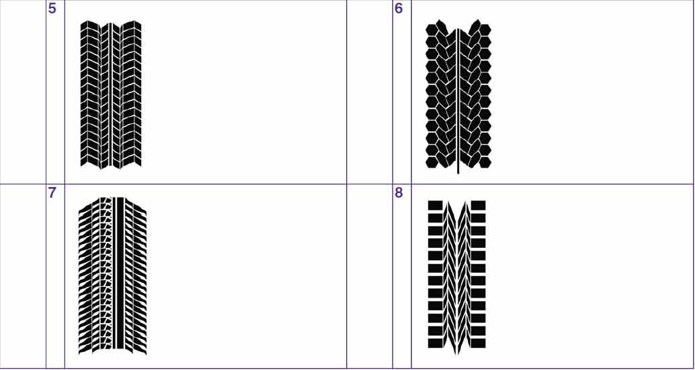

Self-Check 3: Lesson 3

Match the impressions left behind with their likely sources:

rubber boot bear

duck skis

shoes motorbike

bird dumptruck

dinosaur dog

1.



2.

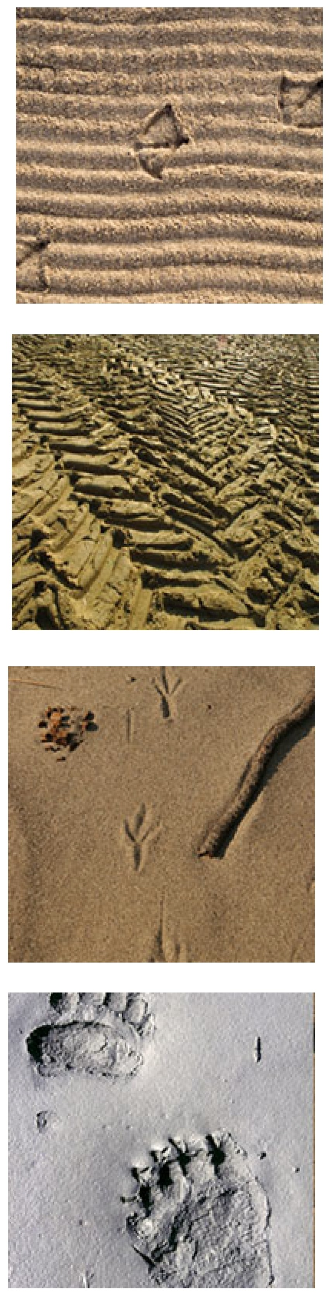

3.

4.

5.

. .....

6.

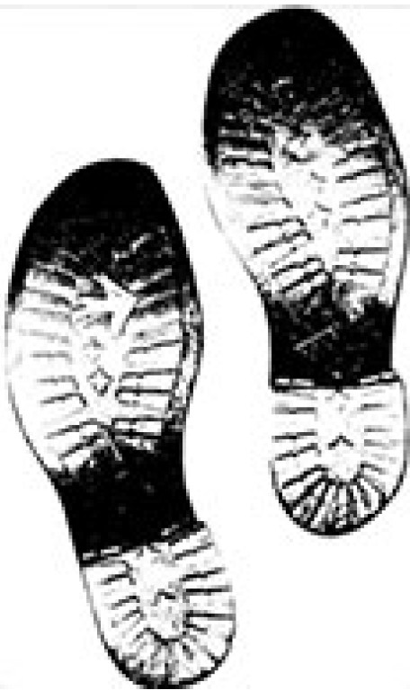

7.

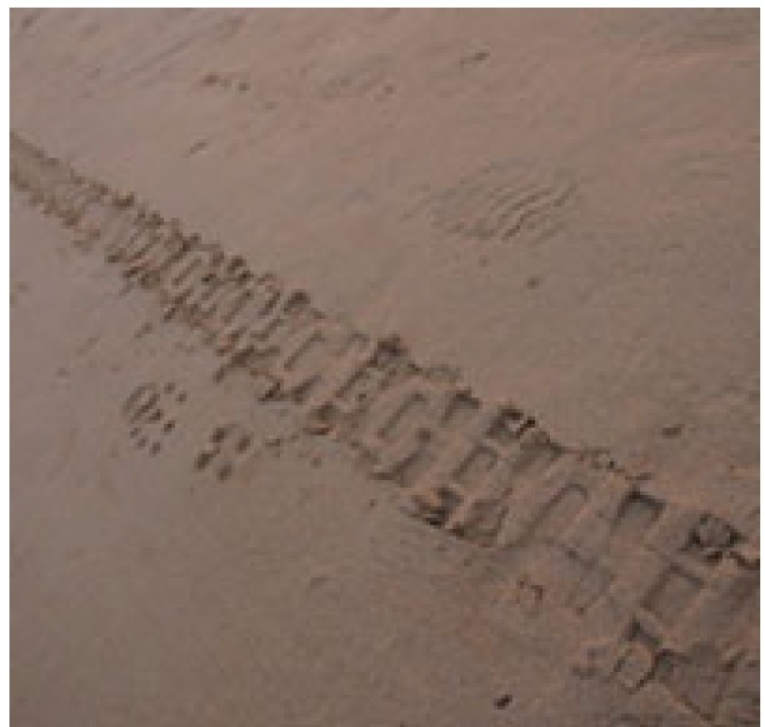

8.

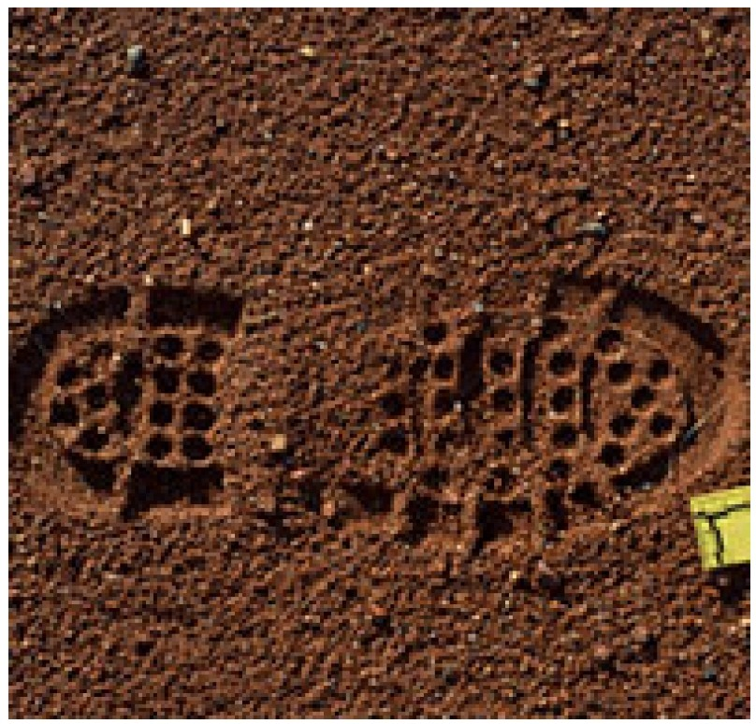

9.

