 Activity 11: Handwriting Characteristics

*How can handwriting be traced to its source?* **Materials**

• blank lined paper

• Analysis of Ransom Note Table

• pen

**Instructions**

**Part 1: Look at your own handwriting.**

1. On the blank lined paper, write your name five times.

• Does the name look the same on all five lines? Explain.

2. Now, try to write your name exactly the same way you wrote it on the last line.

• Were you able to copy your name exactly?

3. Ask a friend or family member to try and write your name the same as you did on the last line.

• What differences do you notice between your friend's copy and your actual handwriting?

**Part 2: Ransom Note Analysis**

1. Read the list of handwriting characteristics described in the Analysis of Ransom Note

Table provided on the next page.

2. After you have read all the characteristics, you will examine a ransom note for these features.

3. Record your observations of each characteristics from the ransom note on the

*Analysis of Ransom Note Table*.

|  |  |
| --- | --- |
| Handwriting Characteristics | Observations from Ransom Note |
| Spacing of words and letters  • Are words and letters close together or far apart? |  |

ADLC Science 6

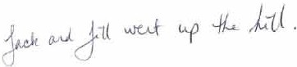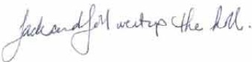

|  |  |
| --- | --- |
| Relative height,width,and size of letters  • Are all the letters the same size? Are some letters noticeably smaller or larger? |  |
| Pen lifts and separations  • Can you tell if the writer lifted the pen to start a new word, or does the pen continue between words? |  |
| Unusual letter formations  • Are any letters written in an unusual way?  • Do some have different slants and angles?  • Does the writer use circles to do the i,or does the writer loop on certain letters at the beginning or the end? |  |

|  |  |
| --- | --- |
| Slant of writing  • Do the letters slant in a certain direction, or are they straight?  • Do all the letters slant the same way? |  |

Ransom Note

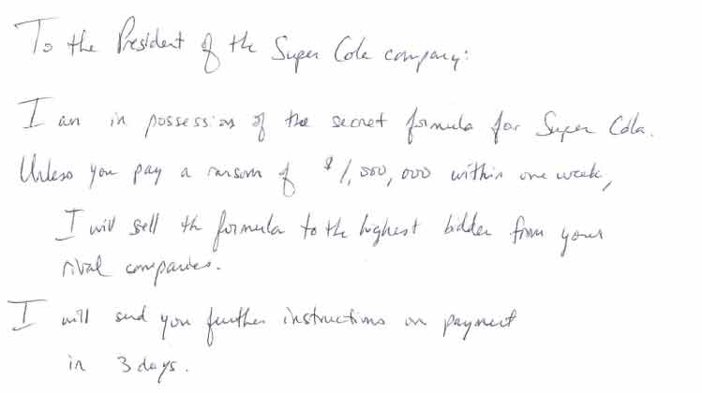

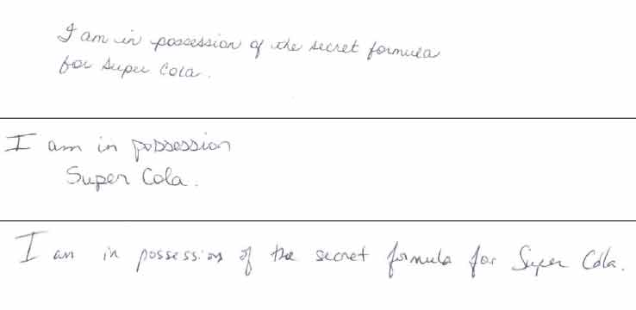

4. Now compare the ransom note to the handwriting samples from three suspects. Which suspect took the formula?

