Exit Pass: Lesson 4



Handwriting and Ink Evidence

Study the two handwriting samples shown below. Explain two similarities and two differences that you observe in the handwriting.

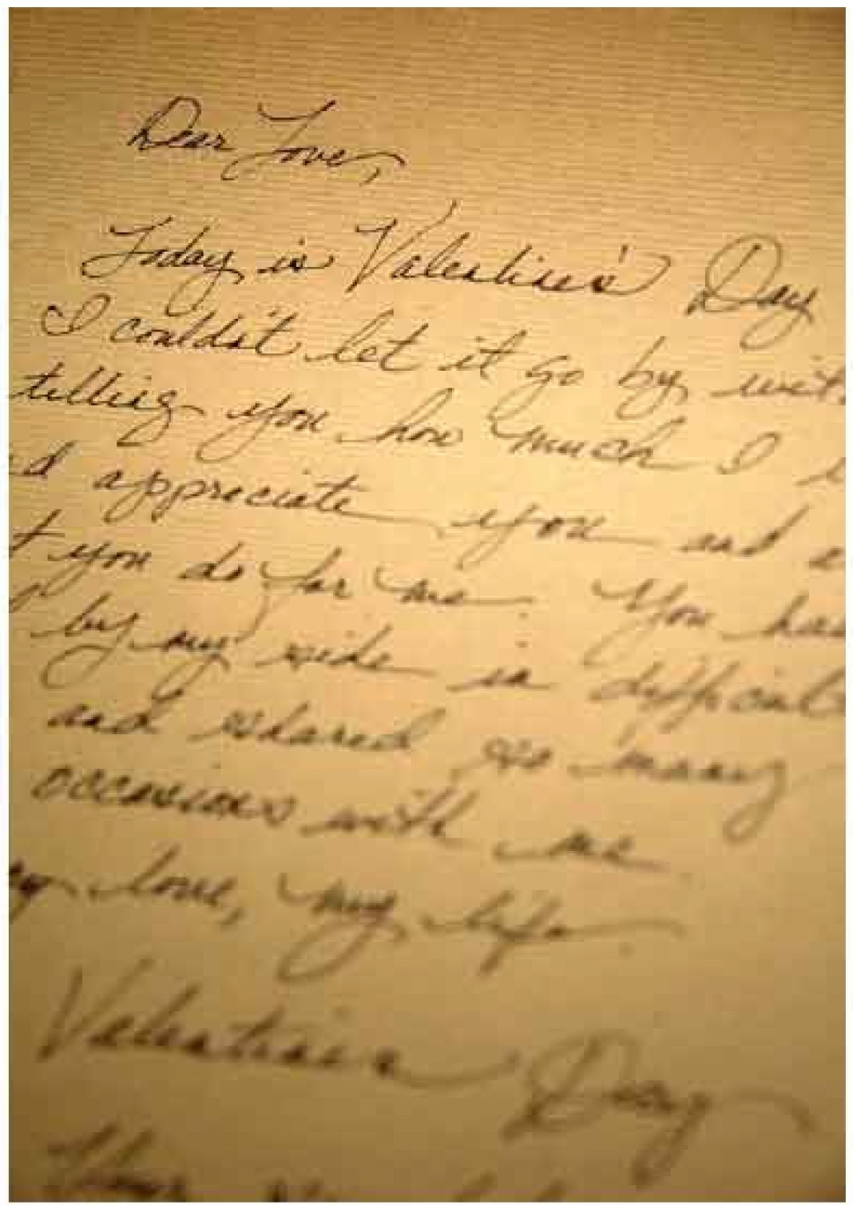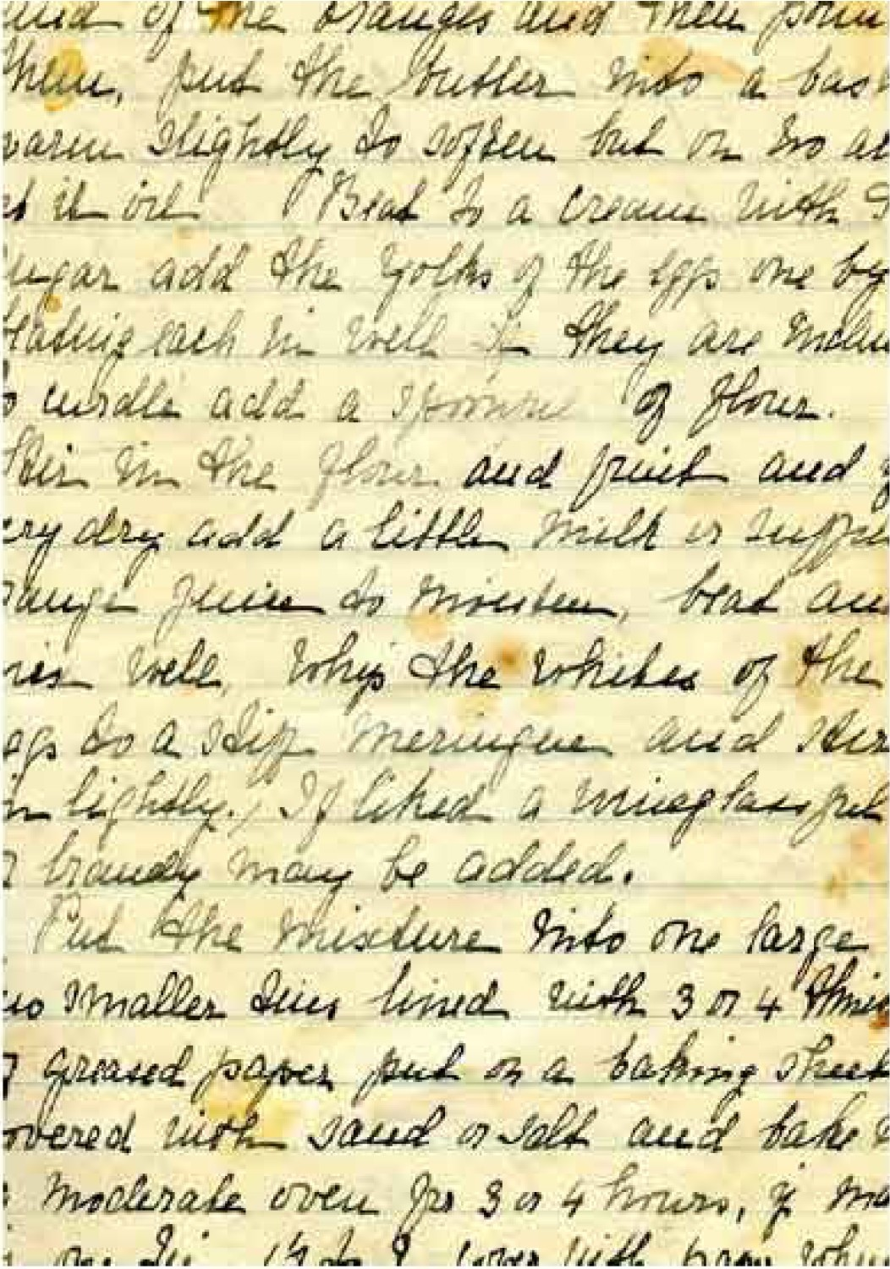

|  |  |
| --- | --- |
| Similarities | Differences |
|  |  |

ADLC Science 6