 Activity 13:I Spy Fibre

*How do various fibres look?*

Fibres are the tiny threads that make up any type of fabric. Fibres can come from natural sources such as cotton or wool.

**Instructions**

1. Examine the various photos of fibres shown below.

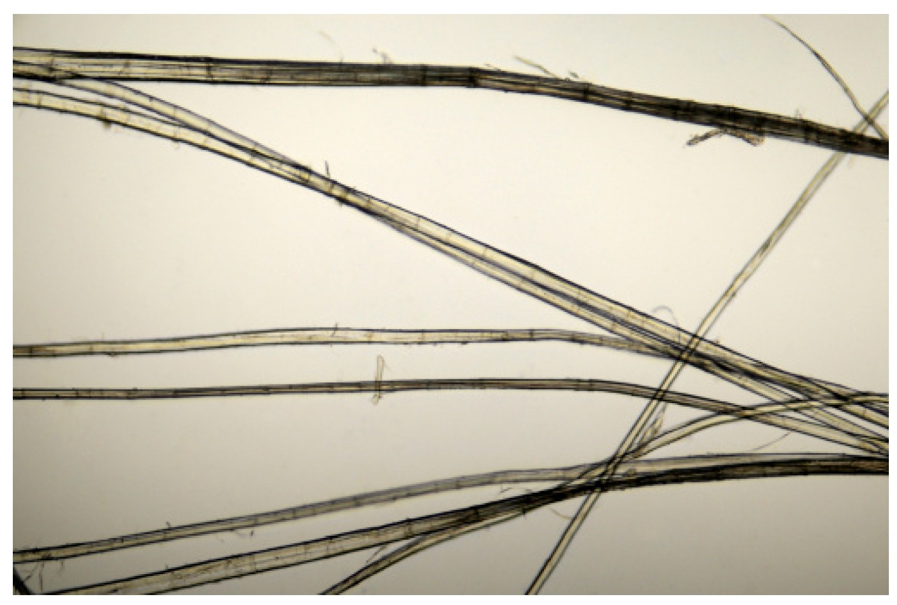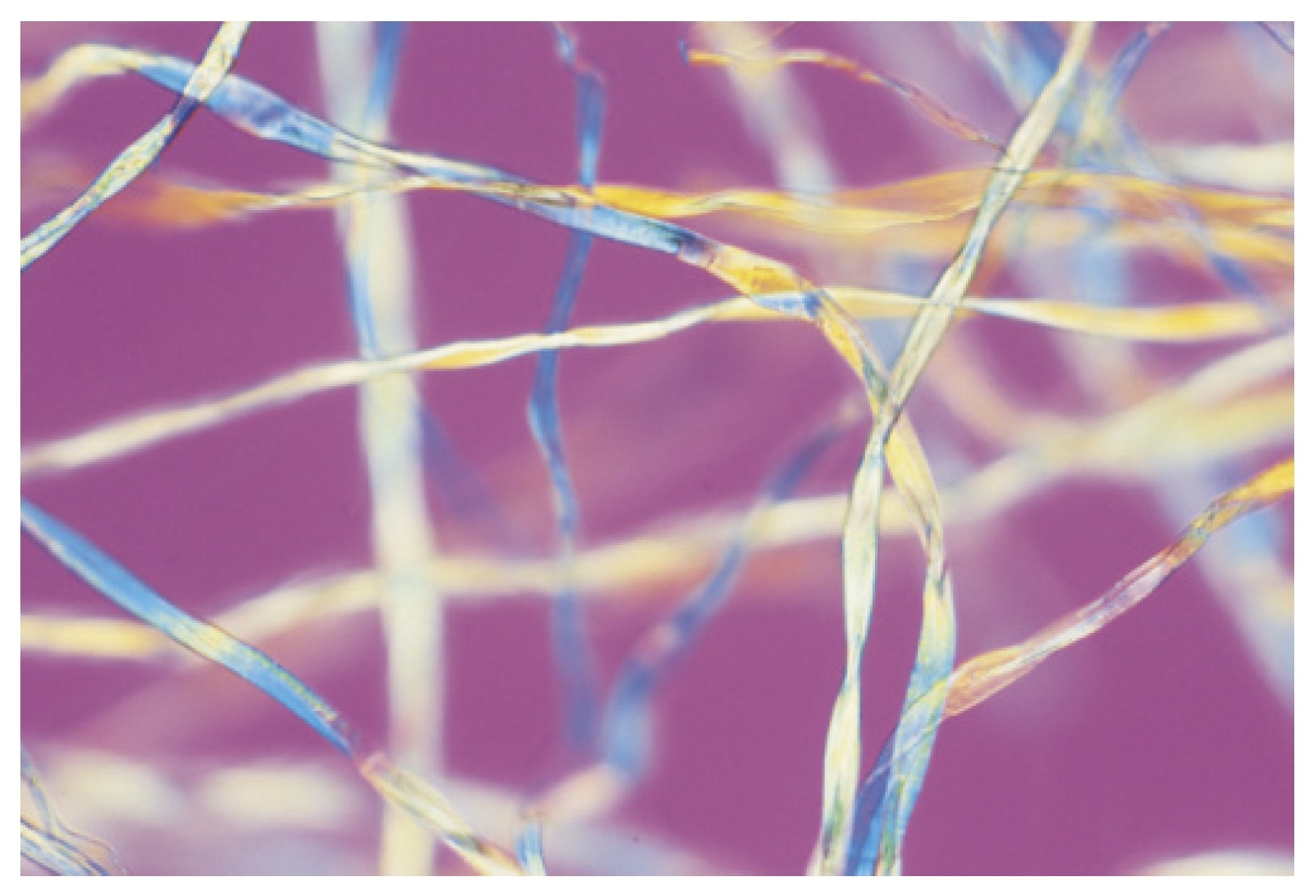

Picture 1 Picture 2

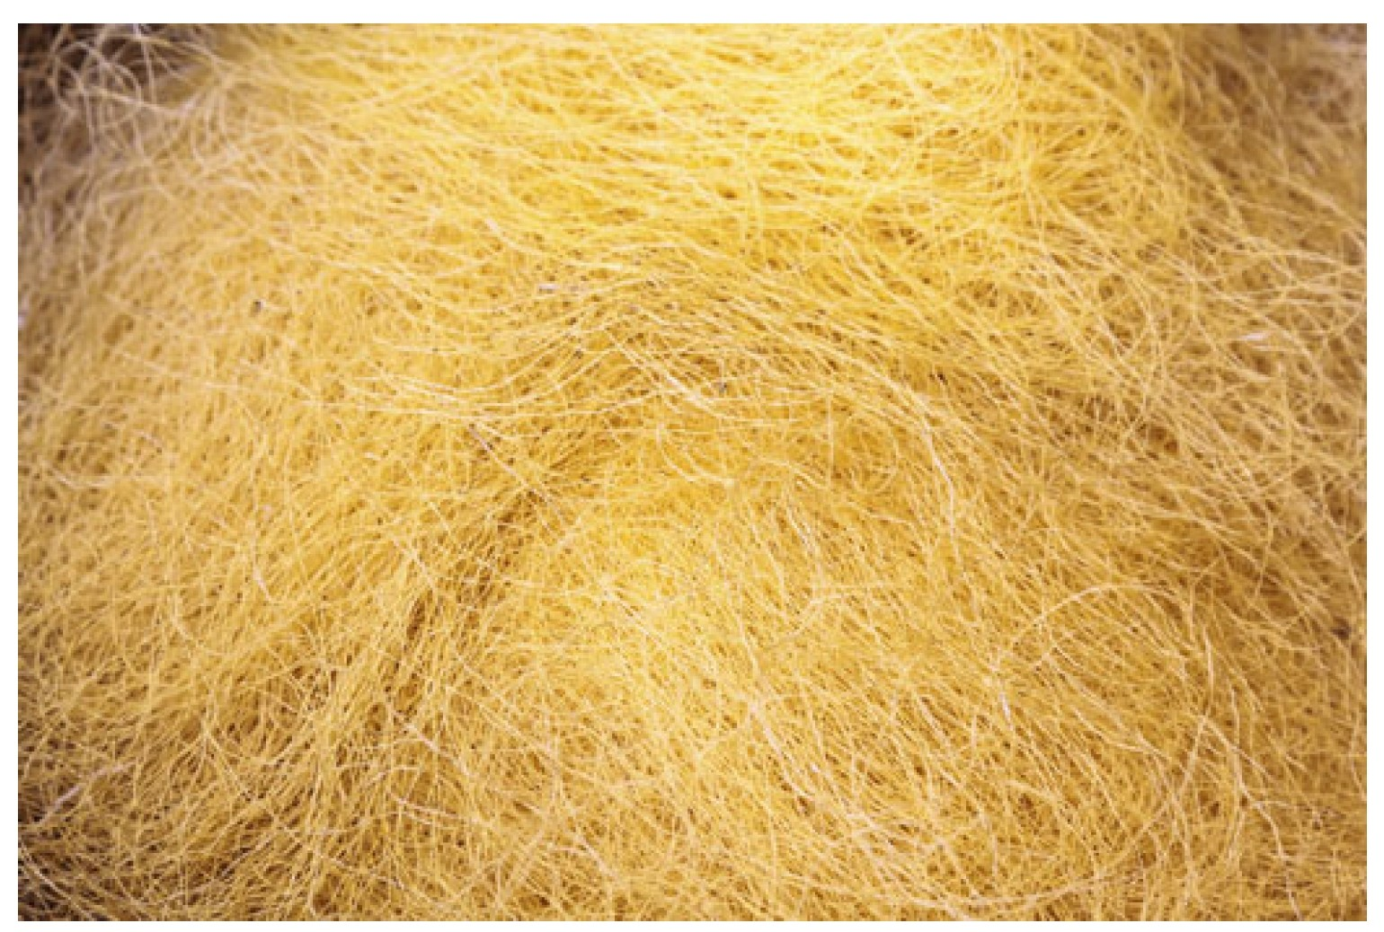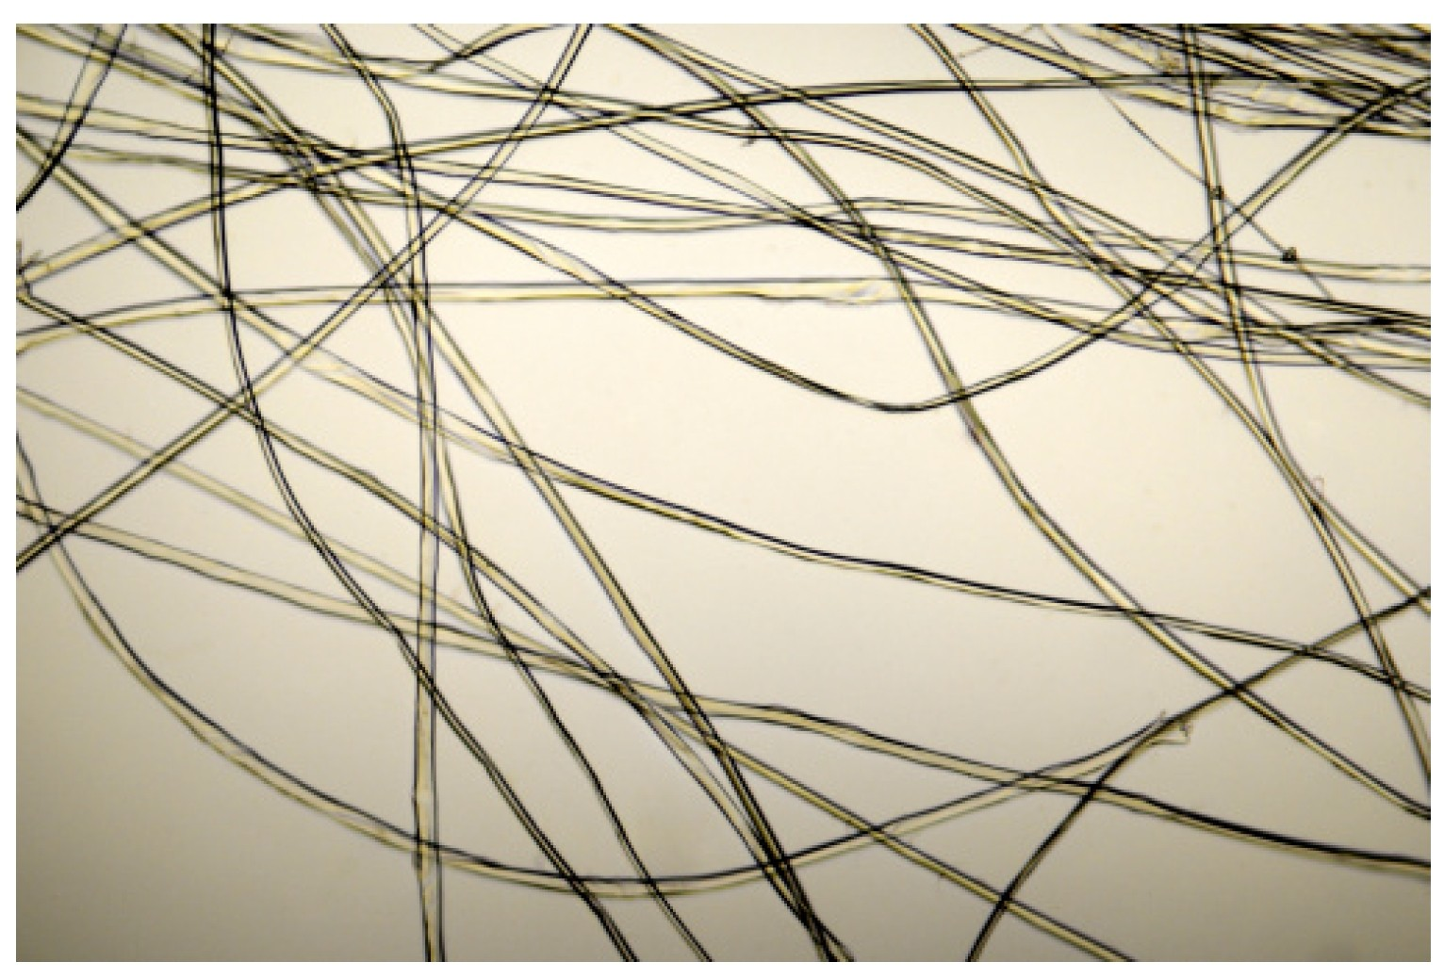

Picture 3 Picture 4

ADLC Science 6

2. Read the description of some fibres.

|  |  |  |
| --- | --- | --- |
| **Fibre** | **Appearance** | **Commonly Found ln...** |
| **Nylon** | thin glass tubes twisted into spirals | ropes, netting, re-usable shopping bags |
| **Silk** | straight, thin glass tubes, completely smooth | scarves, fancy ties, clothing such as ladies blouses or dresses |
| **Cotton** | flat, twisted ribbon | t-shirts, bed sheets, jeans, sweatshirts |
| **Polyester** | long irregular strands with bits of materials sticking out  {not smooth) | track suits, jackets, car upholstery |
| **Wool** | fuzzy and scaly | sweaters, socks, hats, mittens |

3. Match the picture to the type of fibre you think it might be. Picture 1:

Picture 2: Picture 3: Picture 4:

ADLC Science 6