 Activity 14: Soil Evidence

*How can soil evidence be traced to its source?* **Instructions**

1. Study the pictures of various soil samples in the *Soil Sample Table*.

2. In the table, write descriptions for each soil sample.

3. Based on your observations of each soil sample, match each soil sample to one of the locations shown.

**Need a Hint?**

Think about what type of soil you are most likely to find at each of these locations.

|  |  |  |  |
| --- | --- | --- | --- |
| **Soil Sample** | **What Colour(s) is it?** | **Describe the Soil Particles.**  **Need a Hint? Are they big? Small? All the same size? Shiny? Dull?** | **What is in the Soil Sample?**  **Need a Hint? Do you see sand? Rocks? Grass? Clay? Other stuff?** |
|  |  |  |  |
|  |  |  |  |
|  |  |  |  |

ADLC Science 6

**Location Pictures**

Match the pictures with their corresponding soil samples.

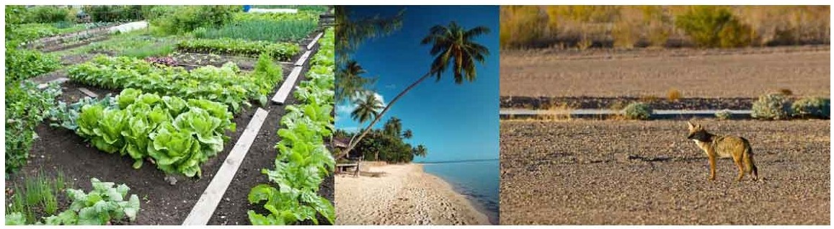

|  |  |
| --- | --- |
| Picture 1 |  |
| -'lcture |  |
| Picture 3 |  |

ADLC Science 6