Exit Pass: Lesson 5



**Fibre and Soil Evidence**

You happened to look out your window one day, and noticed someone borrowed your neighbour's wheelbarrow without asking. The person also happened to "borrow" parts of your neighbour's prize flower garden! You caught a glimpse of the suspect who looks like this:

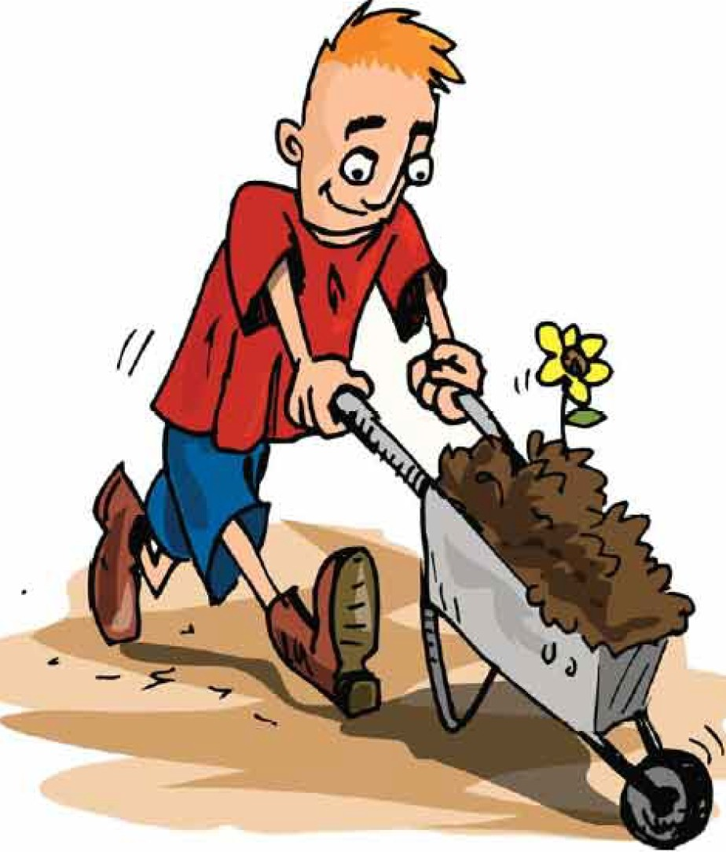

Think about the kinds of trace evidence you most likely expect to find at the scene:

1. Describe the colour and type of fibres the person might leave behind.

2. Describe the kind of soil evidence that would be left behind. What does it look like?

3. What other trace evidence might he leave other than fibres and soil?

ADLC Science 6