 Activity 15: The Case of the Missing Cat

*What are the four types of fingerprints?* **Resources**

• Wonderville: The Case of the Missing Cat:

<http://www.learnalberta.ca/contenUwonckc/html/index.html>

You will need to access/create your free Wonderville account. You will need an adult to help you if you have not created this account already.

**Instructions**

1. Work to solve *Wonderville: The Case of the Missing Cat.*

2. As you are working through *The Case of the Missing Cat,* use the information on the website to help you complete the *The* Case *of the Missing Cat Chart* provided on the next page.

ADLC Science 6

**The Case of the Missing Cat Organizer**

Example

1.

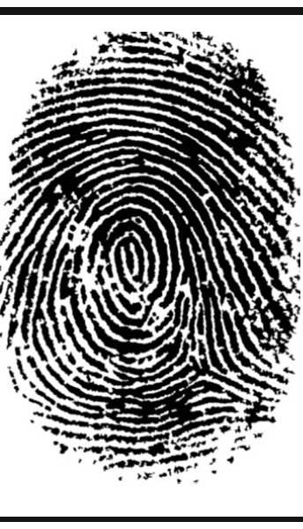

2.

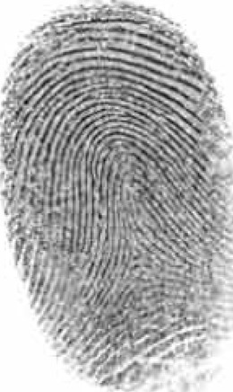

3.

4.

ADLC Science 6

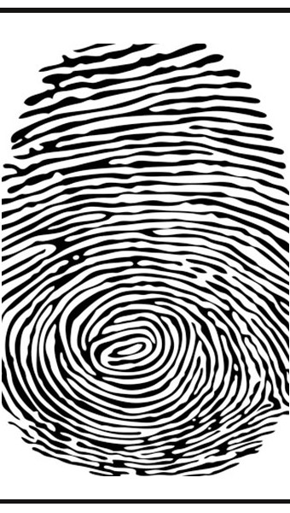

Fingerprint Type and Description