Exit Pass: Lesson 6



**Fingerprints**

Identify and describe each of the fingerprints shown.

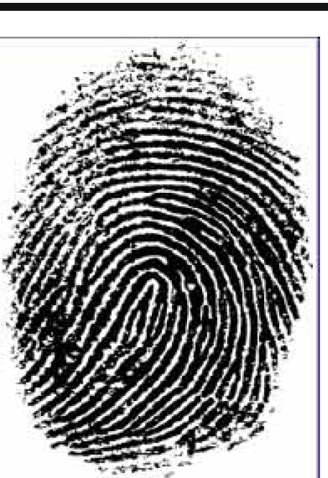

**Picture**

**Fingerprint Type Description**

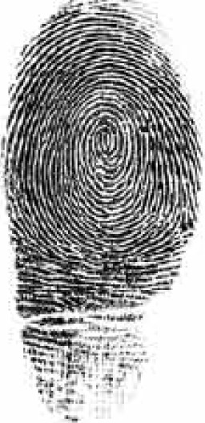

ADLC Science 6