Activity 2: Life in the Forest

What kind of organisms live in the forest, and how are they connected? Materials

• Forestry Images Website

https://www.[forestryimages.org/](http://www.forestryimages.org/)

Instructions

1. Visit the *Forestry Images* website to view various insects, trees, plants, and wildlife that live in the forest. Use the links on the main page to guide you through these categories.

2. As you discover animals, construct a bubble or mind map with various areas of the bubble map representing various groups. You can organize your bubble map any way you want. You can view a sample bubble map below.

3. You need not list every organism you find at the *Forestry Images* website. There are far too many! Challenge yourself to find two examples for each of your groups (for example, two mammals) on your bubble map.

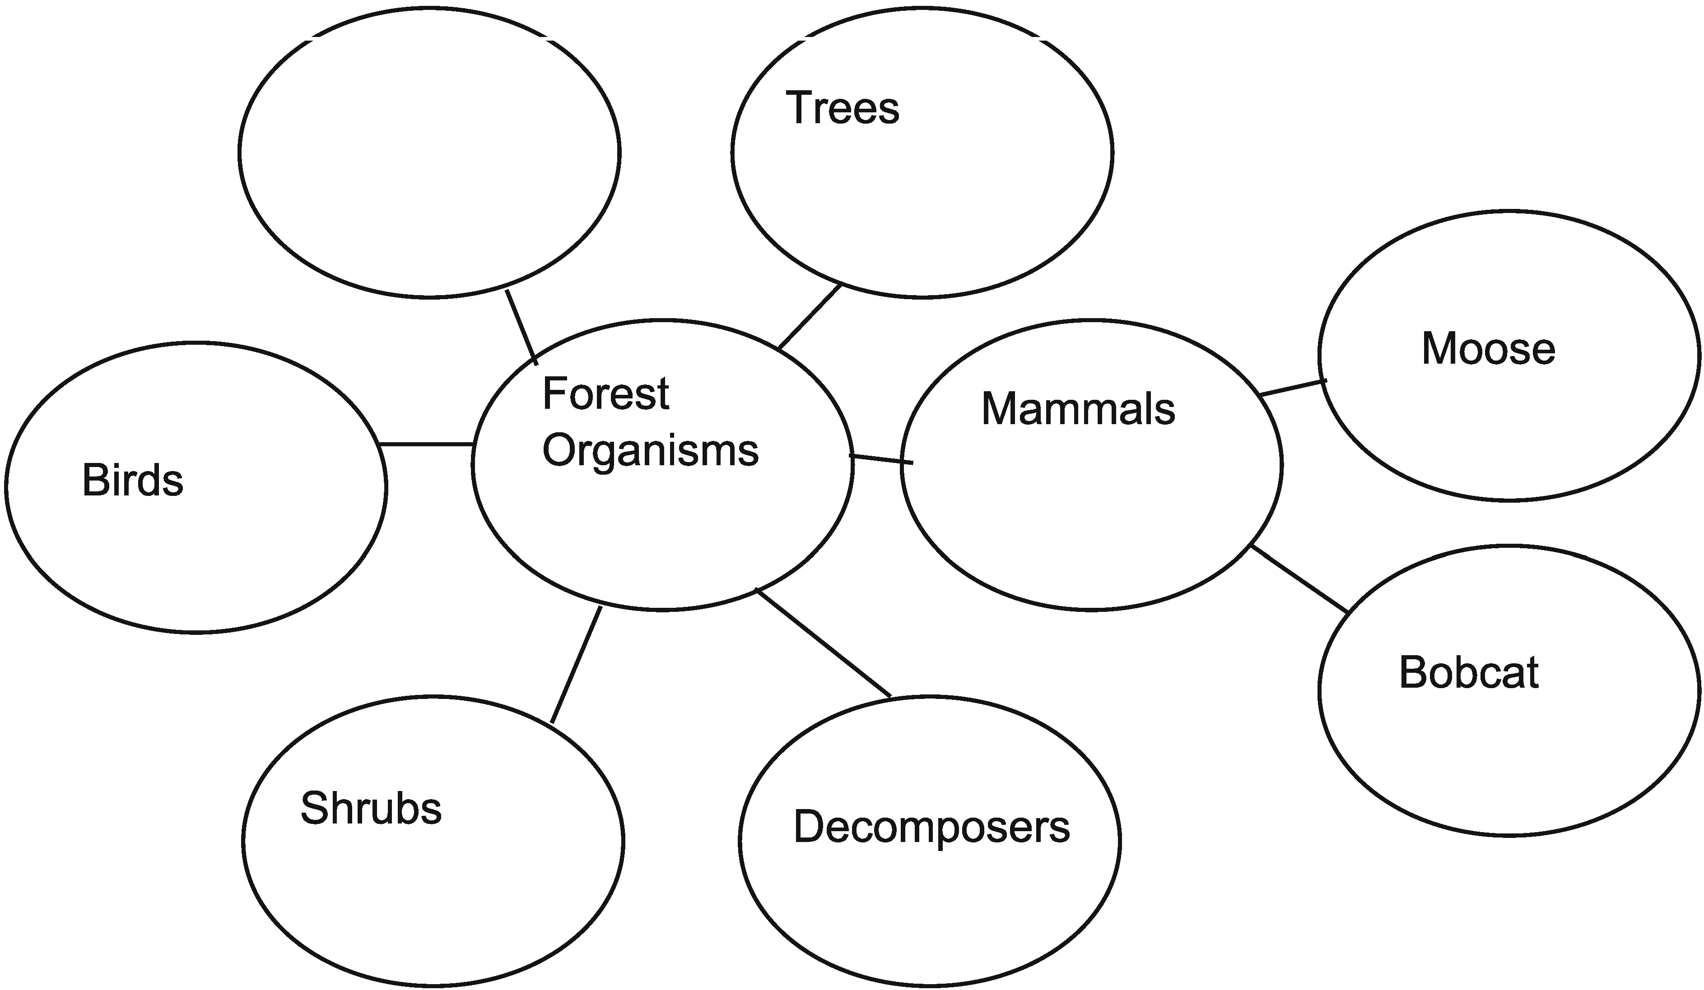

Insects

8 ADLC Science 6

**Bubble Map**

ADLC Science 6