 Activity 3:The Layers of a Forest

What organisms inhabit the various layers of the forest?

Resources

• The Structure of a Forest

[https://www](http://www.thoughtco.com/structure-of-a-forest-130075).[thoughtco.com/structure-of-a-forest-130075](http://www.thoughtco.com/structure-of-a-forest-130075)

• Layers of the Forest

[https://www.youtube.com/watch?v=sau71sd-Hh8](http://www.youtube.com/watch?v=sau71sd-Hh8)

• Port Blakely Trailhead

https://portblakely.com/pb-tree-farms/environmental-education/hq/trailhead1

Instructions

1. Visit the three websites above to view various insects, trees, plants, and wildlife that live in the various layers of the forest.

2. Construct a bubble map using Google Drawing Doc with various areas of the bubble map to represent the various forest layers. Add the organisms as bubbles to your map. If you like, you can add organisms from the previous *Life in the Forest* activity. You can organize your bubble map any way you like, but there is an example of one below.

ADLC Science 6

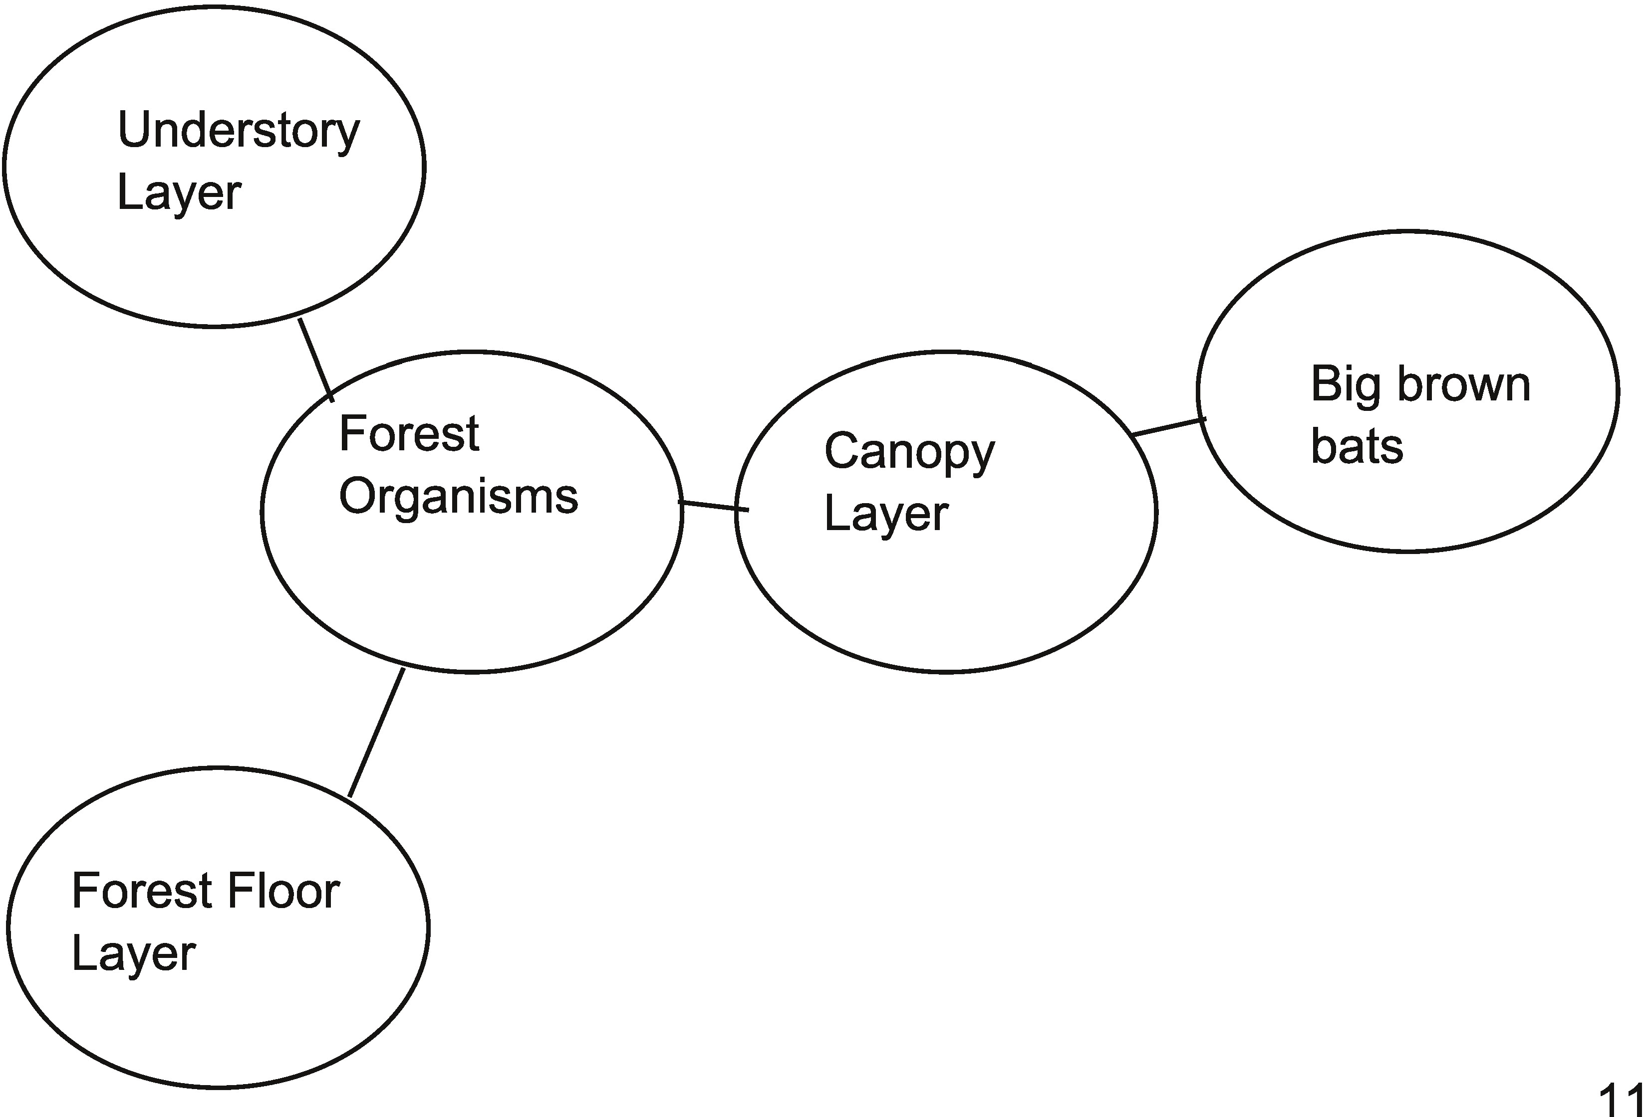

**Bubble Map**

ADLC Science 6