Activity 6: Trees Help to Cycle Water and Nutrients

What role do trees have in various cycles? Resources

• BrainPOP Video: Nitrogen Cycle (username: 0099 password: students}

[https://ww](http://www.brainpop.com/science/earthsystem/nitrogencycle/)w.[brainpop.com/science/earthsystem/nitrogencycle/](http://www.brainpop.com/science/earthsystem/nitrogencycle/)

• Rainforest Water and Nutrient Cycles:

<http://www.bbc.co.uk/schools/gcsebitesize/geography/ecosystems/tropical_rainforests_rev>

2.shtml

Instructions

1. Watch the *BrainPOP Video: Nitrogen Cycle* website, and use the information to answer the fill-in-the-blank questions and multiple-choice items.

2. Visit the website *Rainforest Water and Nutrient Cycles,* and read the page carefully. Use the information on the page to answer the fill-in-the-blank and multiple-choice items.

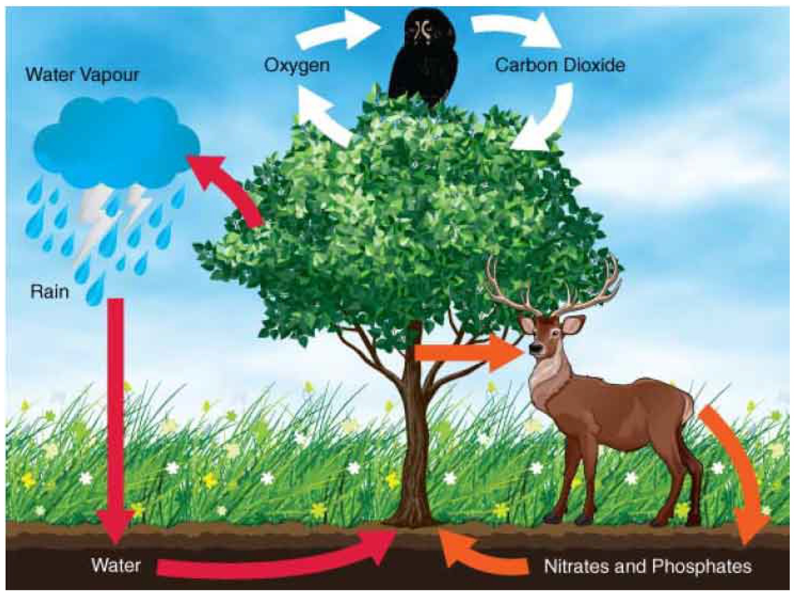

ADLC Science

**Water Cycle**

What role do trees have in water and nutrient cycles?

Use the words from the list below in the following sentences. Words can be used more than once or not at all.

roots leaves food condensation evaporation

1. Rain falls to the ground and tree absorb the water.

2. Trees use water to make

3. Water passes out through the into the atmosphere where it can turn into clouds and rain again.

4. When water vapour cools in the atmosphere, it forms water

5. During the process of , water becomes water vapour.

Phosphorus Cycle

Use the words from the list below in the following sentences. Words can be used more than once or not at all.

phosphorus rains

fertilizer trees

rocks

6. Phosphates are found in

7. When it , phosphorus leaches from rocks into the soil or into the oceans.

8. helps develop healthy root systems in plants and helps plants convert energy.

9. If phosphorus runs into the ocean, it settle on the ocean floor and is lost to

, humans, and animals.

10. When crops are taken away and sold,

must be used to add phosphates back into the soil.

ADLC Science 6