 Activity 9: Tree Products

How many tree products can you spot in the images below?

To be a good detective or forensic scientist, you must have good observation skills. Complete the activity, using the links provided (in the lesson and below).

Resources

• From the Forest Magazine [http://ecosystems.psu.edu/youth/sftrc/lesson-plan-pdfs/from­](http://ecosystems.psu.edu/youth/sftrc/lesson-plan-pdfs/from)

the-forest

• The Forest Academy Trees in Our Lives

[https://www.theforestacademy.com/download-pdf-selection/#.Wo-PhqinFPZ](http://www.theforestacademy.com/download-pdf-selection/#.Wo-PhqinFPZ)

Instructions

1. Go to the *From the Forest* magazine. View *The Products We Get From Trees.* Read the

*Trees in Our Lives section of the Forest Academy* website.

2. List the many products you see that come from trees below.

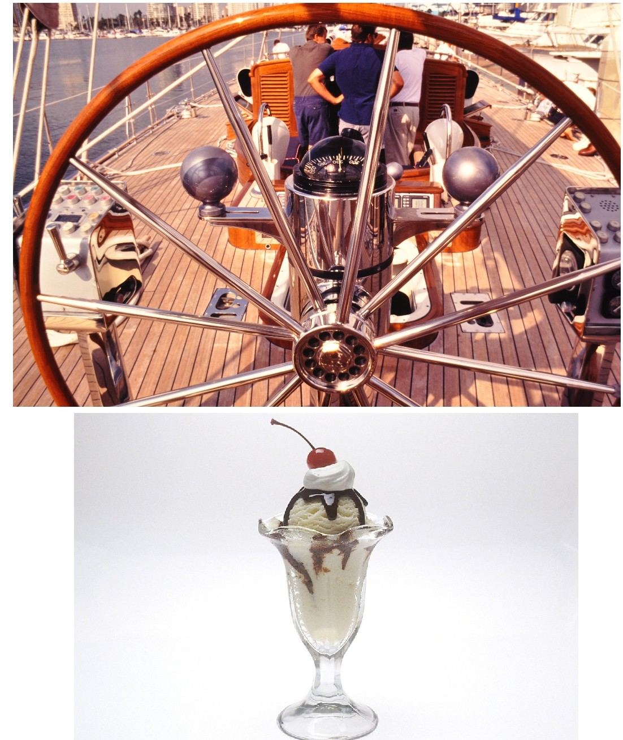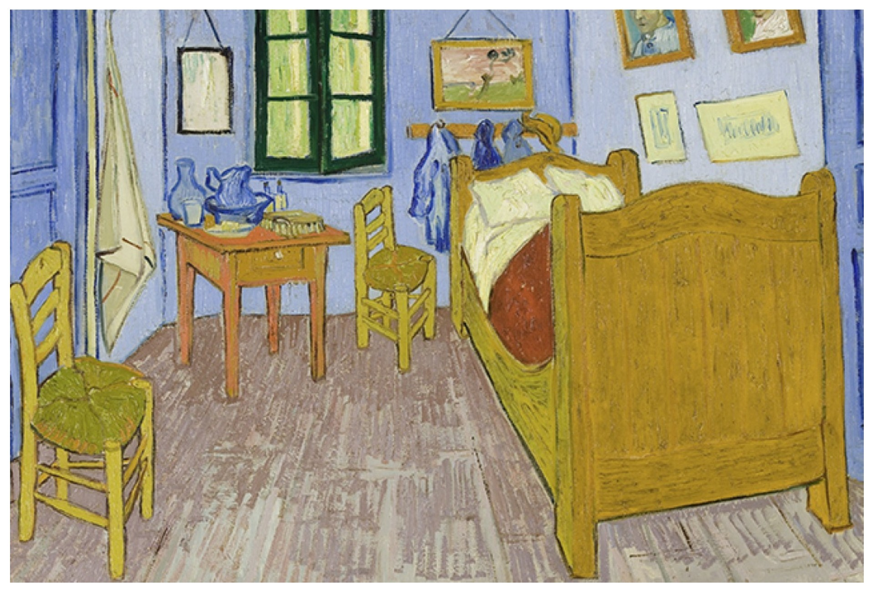

Vincent Van Gogh

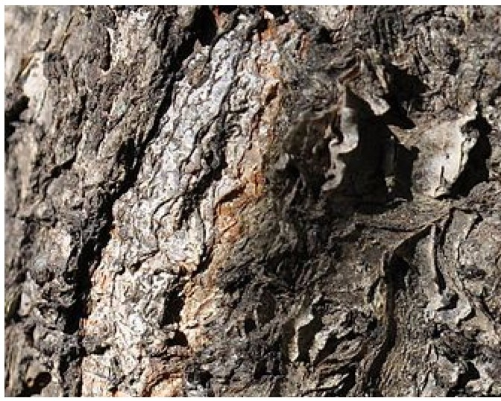

The Bedroom 1889

Nanocellulose frnmwuod

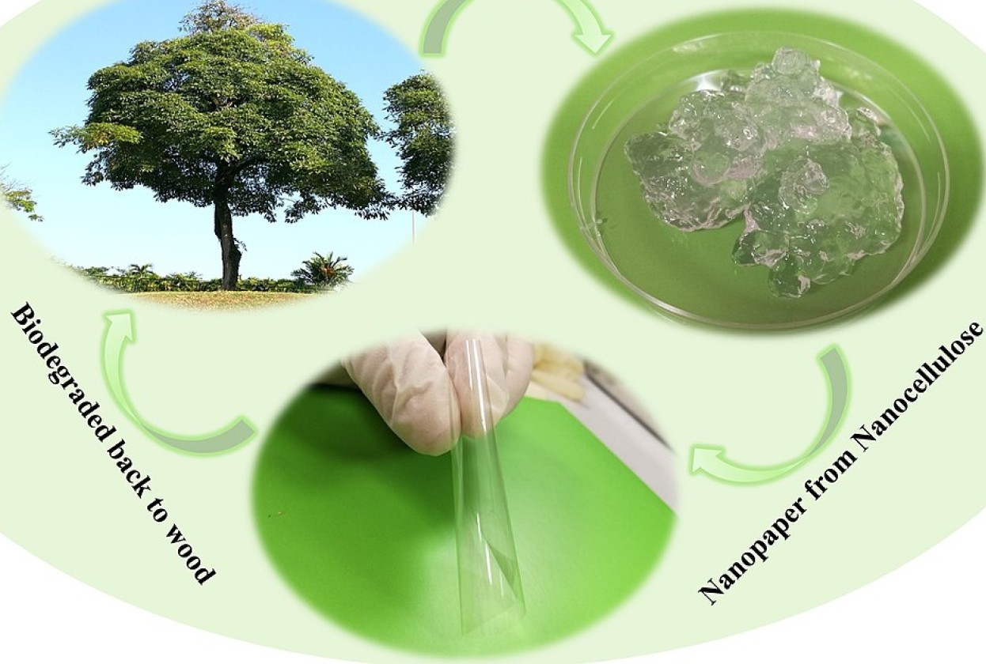

|  |
| --- |
|  |

ADLC Science 6