 Activity 11: Trees, Trees, and More Trees!

What are the main differences between deciduous and coniferous trees? Materials

Use the following links to complete the activity.

• Dr. Arbour's Laboratory

<http://extension.illinois.edu/trees3/lab.html>

• Trees in Canada

https://treecanada.ca/en/resources/trees/

Instructions

1. Visit the *Dr. Arbor's Laboratory* website. Go through Dr. Arbor's Laboratory to see how trees are different. Also, be sure to check 'Tree Basics' tab at the top of the page (look for small white triangles to move from page to page). Give particular attention to the differences among tree types.

2. Complete a Venn Diagram to identify similarities and difference between coniferous and deciduous trees.

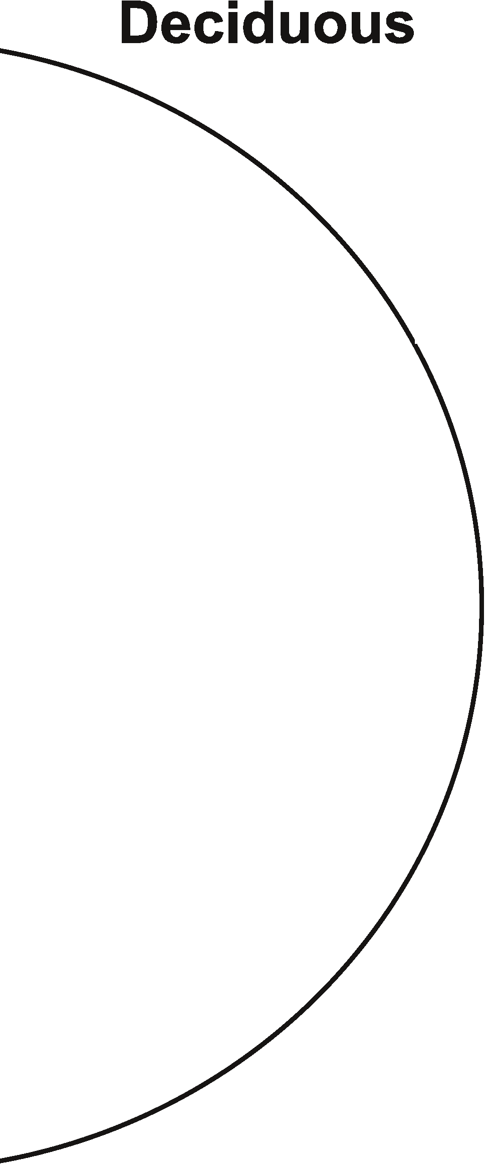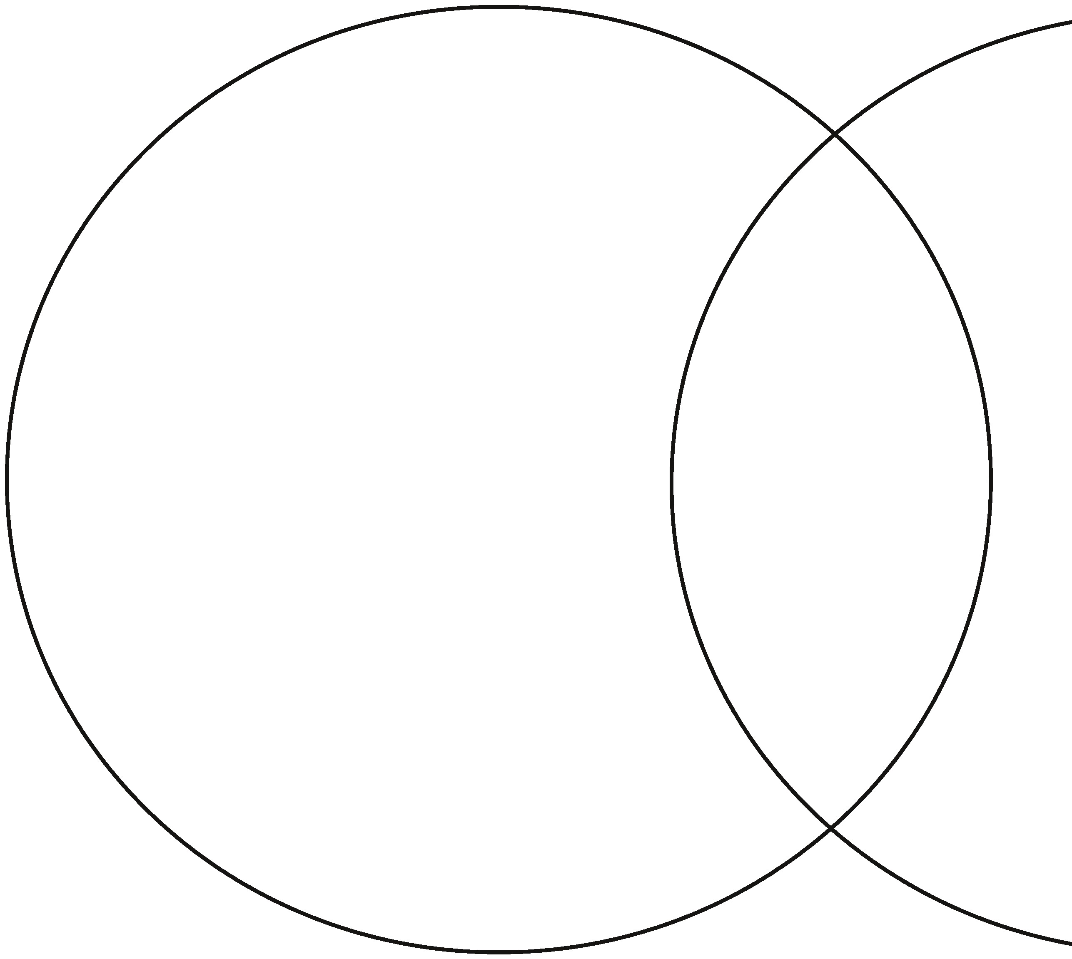

Coniferous

ADLC Science 6