Exit Pass: Lesson 5



How can you identify various trees? Questions

1. A friend gives you a package of seeds as a present. The package is marked clearly as

"annual". Your friend says, "I hope you plant those seeds and enjoy the plants for the next

20 years."

Why is your friend mistaken?

2. Are the trees in your neighbourhood coniferous or deciduous? How can you know the difference? If you do not have trees in your neighbourhood, answer this question for the nearest place you know of that has trees.

3. No classification system is perfect. Although most conifers are evergreens, that is not always the case. The photo shows a branch of a larch tree, sometimes called tamarack. It has green needle-type leaves, and it produces cones. However, larch leaves change colour and fall off in autumn. Is the larch a coniferous tree or a deciduous tree? Explain your answer.

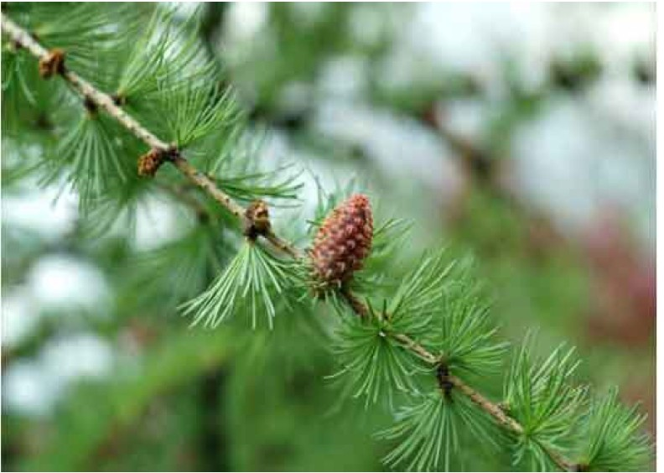

ADLC Science 6