Unit 4 Name:

Date:

4-2: Trees Presentation

**Question**What makes trees unique?Answer the following questions

1. Construct a pamphlet or PowerPoint with relevant images and diagrams in which you identify and explain the following:• the difference between trees and other plants? /1• the difference between both deciduous and coniferous trees. /2• how trees are involved in the water cycle /4• how the process of photosynthesis works /5• how food (sugar), water, and nutrients are transported in the tree and in which

layers of the trunk they are transported /2• the purpose of the roots, trunk, leaves, and seeds /4

|  |
| --- |
|  |

Total: /18 marks

1. Identify these unknown leaves below. Use the dichotomous key on the next page to identify the trees from which the leaves come. /9 marks

A B C

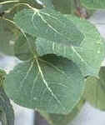 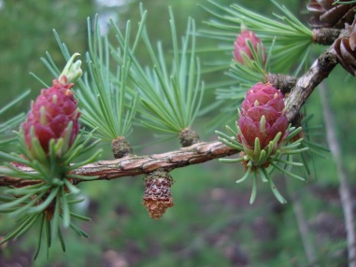 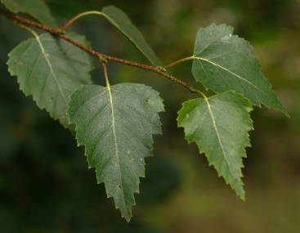

D E F

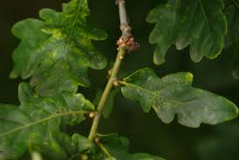 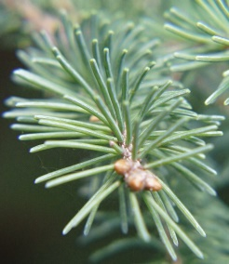 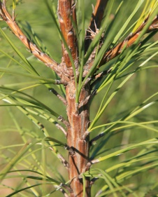

G H I

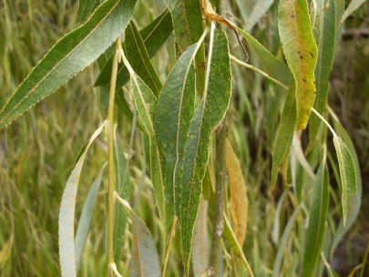 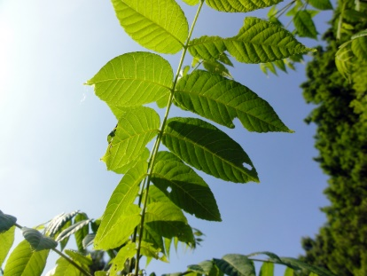 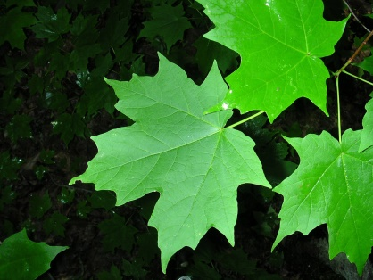

|  |  |
| --- | --- |
| **Dichotomous Tree Key** | |
| 1a. If the leaves are needle-like (conifer)  1b. If the leaves are broad and flat (deciduous) | Go to 2  Go to 5 |
| 2a. If the needles are not clustered or bunched – (they are single on twigs)  2b. If the needles (leaves) clustered or bunched on twigs | Go to 3  Go to 4 |
| 3. If the needles are four-sided and sharp-pointed | Spruce |
| 4a. Clusters of 2-5 needles  4b. Clusters of greater than 10 | Pine  Larch/Tamarack |
| 5a. Leaves opposite on stem  5b. Leaves alternate on stem | Maple  Go to 6 |
| 6a. Leaves simple  6b. Leaves compound | Go to 7  Black Walnut |
| 7a. Leaf edges (margins) not deeply cut, lobed, or toothed  7b. Leaf edges (margins) deeply cut, lobed, or toothed | Go to 9  Go to 8 |
| 8. If your tree has lobed leaves | Oak |
| 9a. Leaves very narrow, 4 or 5 times as long as wide  9b. Leaves broad | Willow  Go to 10 |
| 10a. If the stem appears to be flattened  10b. The stem is not flattened | Aspen  Go to 11 |
| 11. If the leaf appears serrate, and the base is slightly heart-shaped | Birch |

1. Using the diagram below answer the following questions.

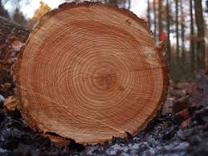A. About how old was this tree when it was cut?(/1 mark)

|  |
| --- |
|  |

B. If the tree were alive, draw an arrow labelled A to where the tree's new growth would be?(/1 mark)

|  |
| --- |
|  |

C. Draw an arrow labelled B to identify where the tree's first year of growth is shown.(/1 mark)

|  |
| --- |
|  |

D. Draw an arrow labelled C to identify the tree's growth during a rainy season. (/1 mark)

|  |
| --- |
|  |

Total: /31 marks

Save Your File

Name your file in this format: 4-2_(jsmith)sc6-uniquetrees and save your file to your Trees and Forests Notebook folder. Submit to the appropriate Submission folder when completed.