 Activity 14: Deforestation: The Forest Sponge

Are human actions such as deforestation harming or helping forests? What is a filter?

Materials

• three plastic plant pots

• three 1-litre jars (the pot must fit into the neck of the jar, but should not slip through.

• four paper towel or paper coffee filters

• potting soil

• cup

• water

• ruler

• spoon

Procedure

1. In Pot #1, cut a circle from one of the coffee filters about the size of the bottom of the flower pot. Punch four holes in it with a pencil. Place the filter in the bottom of the pot. Repeat for Pot #2. This filter represents the roots of a tree. Pot # 3 will have no filter.

2. Pour one cup of potting soil into each pot. Measure the depth of the soil in each pot and record the amount on the Erosion Chart on the next page.

3. Cover the soil in Pot #1 with a second circle cut from a coffee filter. Do not punch any holes in this filter. This represents the layer of plants that grow on the forest floor. Do not put any filters on top of the soil in Pots #2 and Pot #3.

4. Sprinkle 500 ml of water into each plant pot. This is the rain. Allow the water to drain through the plant pot.

5. After the water has drained, measure the amount of soil that remains in each flowerpot and the amount of water that drained into each jar. Record how much soil is in the water.

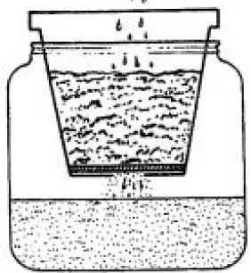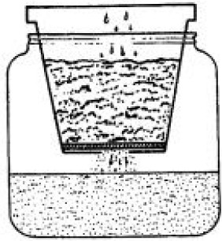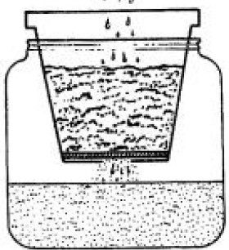

.

.

.

,

.

"

Jar 1 filter on bottom of pot and filter on top of soil

Jar 2 filter on bottom of pot

Jar 3 no filters

ADLC Science 6

Observations

Erosion Chart

|  |  |  |  |
| --- | --- | --- | --- |
| Soil Erosion | Pot 1 | Pot2 | Pot3 |
| Amount of soil added  (depth in cm) |  |  |  |
| Amount of water  added (in mL) |  |  |  |
| Amount of soil in pot  after water added  (depth in cm) |  |  |  |
| Amount of water in jar  after water  added (depth in cm or volume in mL) |  |  |  |
| Water description |  |  |  |

1. What do your results tell you about the importance of trees in forests?

2. What do your results tell you about the importance of the forest floor?

3. What might be the result of the human action of deforestation?

ADLC Science 6