

Activity 15: The Way We Use Forests

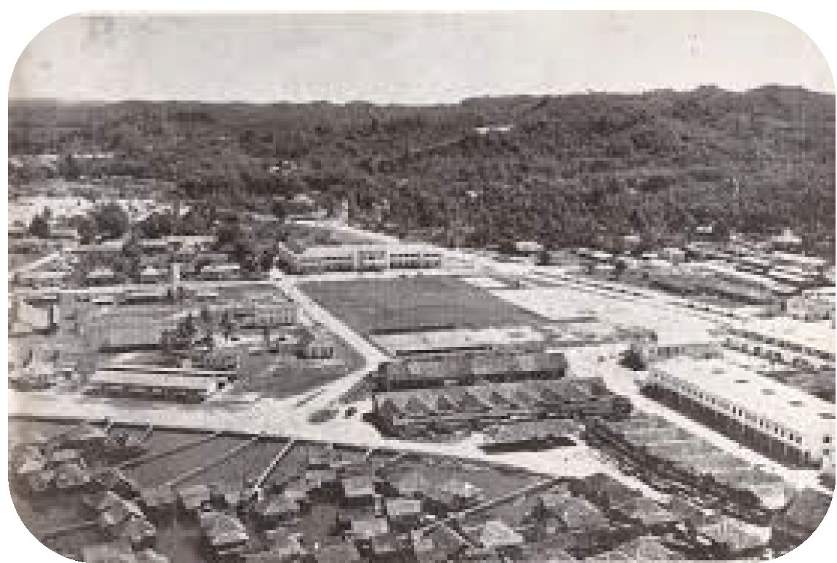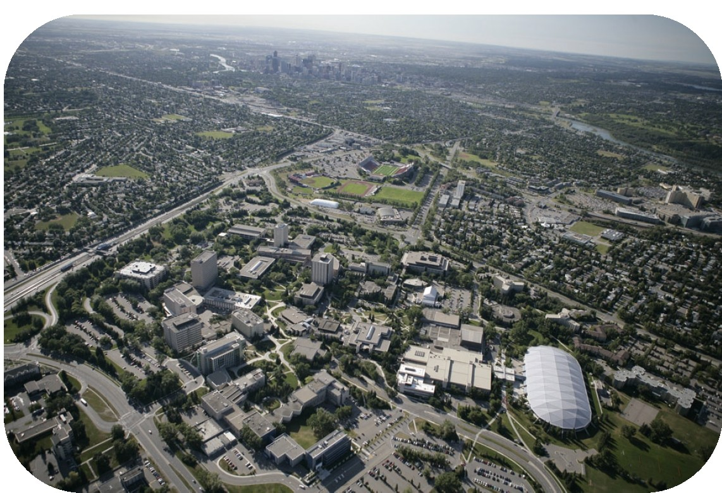

How has tree and forest use changed throughout history? Materials

University of Calgary campus in 1950 and in 2008.

Instructions

1. View the two digital orthophotographs of the University of Calgary campus above. One photo is from 1950. The other is from 2008.

2. Count the roads or streets you see in each image.

3. Count the number of buildings you see in each image.

4, How has the number of trees or area of forest changed?

5. How might this change in land use have affected the community?

6. Predict how this land will look in 2055?

ADLC Science 6