Lesson 1: Pythagorean Theorem

Review what you have learned prior to completing the Lesson Assignment.

Key Ideas
- The formula used for the Pythagorean Theorem: a² + b² = c²

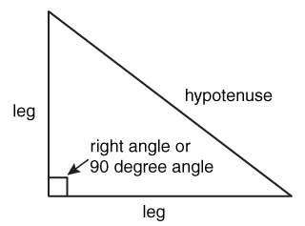
- The sum of the squares of legs of a triangle with be equal with the square of the hypotenuse.
- The hypotenuse is always the longest side of a right angled triangle
- By using the Pythagorean Theorem, you can solve for the third side (leg or hypotenuse) if the other two side lengths are known.
- The Pythagorean Theorem can only be used with right angled triangles.
- The sign for a right angle is a small square in the corner of the 90 degree angle.
Key Terms
- legs
- hypotenuse
- right angle
- Pythagorean Theorem

