Lesson 2: Area Summary

Review what you have learned prior to completing the Lesson Assignment.

Key Ideas
- Area is measured in square units (example: cm²).
- When solving area problems, after looking at or drawing a diagram, always include the formula or formulas to be used in your solution.
- Area can be estimated by taking the average of an overestimation and an underestimation.
- Area formulas do not need to be memorized as they will be provided on a formula sheet.
- For composite figures, the areas of simple shapes can be added together.
- All dimensions must be in the same unit before area can be calculated.
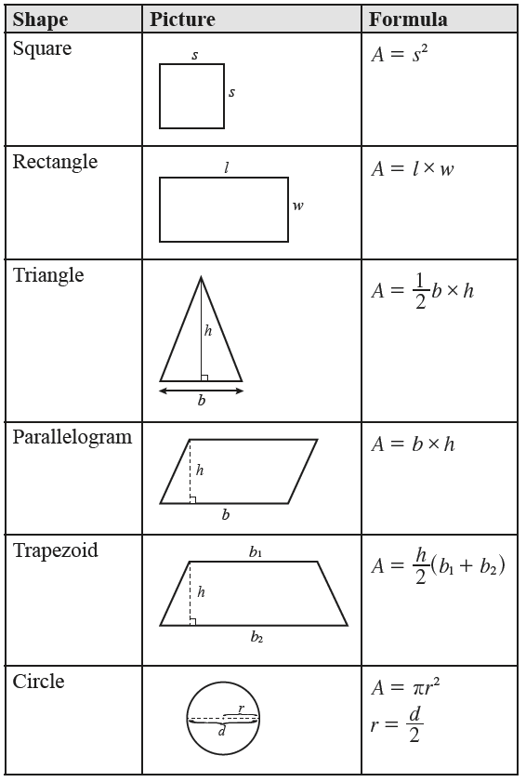
Key Terms
- area
- height
- length
- radius
- diameter
- base
- parallelogram
- trapezoid
- composite figure
- parallel

