**Practice Assessment**

*Practice* provides practice and allows you to self-reflect on your conceptual understanding of the *Lesson* skills. You will mark your work for *Practice* in each Workbook according to the following rubric.

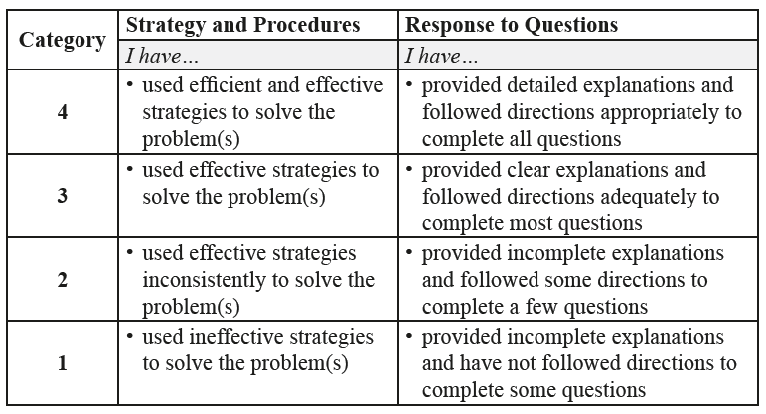

Complete *Practice* exercises using your best work, showing all relevant steps needed to arrive at your solution. Refer to the *Module* to review lesson instructions. Contact your teacher for assistance

or clarification as needed, or to investigate the topic further.

Check and correct your work using the solutions provided by the answer key.

*Practice* is worth 8 marks; your mark can help you gauge your understanding of *Lesson* material.

After you have assessed your work, reflect on your understanding of the concepts addressed in the *Practice* exercises in the table provided.

NAME:

Self-assessed mark: /8

**Lesson 1.1: Arithmetic Sequences**

Complete the *Practice* below. When you have completed all the questions for *Lesson 1.1 Practice – II* with your best work, mark your work by first comparing your answers to the solutions provided by the answer key. Then, apply the rubric found at the beginning of the *Practice*.



1. Given  and  of an arithmetic sequence, determine the values of the common difference, *d*, and the first term, .  
     
   Answer:
2. Kyle is saving money to buy a new electric guitar. He had $225.00 saved by the fourth week and $360.00 by the 13th week.
3. Assuming his savings amount increases in an arithmetic sequence, write the general formula that relates the amount of money saved to the number of weeks saving. Be sure to define the variables.  
     
   Answer:
4. The electric guitar Kyle is looking to buy costs $1 250.00. For how many weeks does Kyle need to save to achieve this goal?  
     
   Answer:
5. What assumption is made in order to answer part b.?  
     
   Answer:
6. How much money did Kyle have in his savings account before he started saving for the guitar?  
     
   Answer:
7. Use the graph below to answer the following question.  
     
   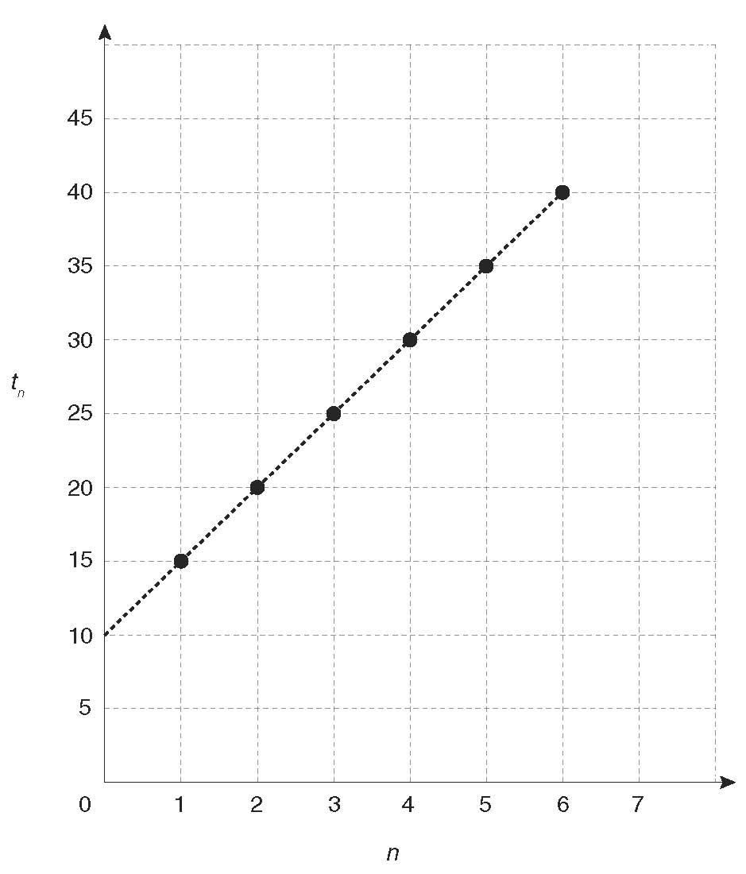  
   1. List the first five terms of the sequence in the table.

|  |  |
| --- | --- |
| ***n*** |  |
| 1 |  |
| 2 |  |
| 3 |  |
| 4 |  |
| 5 |  |

* 1. Write the general term of this sequence.  
       
     Answer:
  2. Calculate the slope of the graph. How is it related to the general term?  
       
     Answer:
  3. Determine the *y*-intercept of the graph. How is it related to the general term?  
       
     Answer:

Mark your work for *Lesson 1.1 Practice – II* using the solutions provided in the *Unit* *Resources* Folder at the bottom of the online *Table of Contents* for this *Unit*. Then, apply the rubric found at the beginning of the *Practice*.

Transfer your self-assessed mark to the beginning of the *Practice*.

Reflect on your understanding of the concepts addressed in the *Practice* exercises in the table provided.

|  |  |  |  |  |
| --- | --- | --- | --- | --- |
| Question Number | Got it! | Almost there… | Need to retry or ask for help. | Similar questions from  *Pre-Calculus 11* |
| 1 |  |  |  | p.16 #3, 4ac |
| 2 |  |  |  | p.18 #16, 19, 21 |
| 3 |  |  |  | p.17 #7 |

You may proceed to *Explore Your Understanding Assignment* on the next page.

**Note:** Before you complete *Explore Your Understanding*, you may review your skills and get more practice by completing the following problems in *Pre-Calculus 11*.

* Page 16 #1, 2ac, 3, 4ac, 5bd, 7, 8, 10, 11, 16, 19, and 21