NAME:

**Lesson 1.1: Arithmetic Sequences**



This assignment includes multiple choice and short answer questions. For multiple choice questions, select the best answer. Each is worth 1 mark. Marks assigned to short answer questions are indicated for each question. Be sure to show all necessary work.

**/1** 1. List the first four terms in an arithmetic sequence where  and .

1. 7, 27, 47, 67
2. 7, 29, 51, 73
3. 22, 29, 36, 43
4. 22, 44, 66, 88

Answer:

**/1** 2. Determine the number of terms, *n*, in the arithmetic sequence 16, 13, 10, …, $-$ 116.

1. $-$ 3
$44$

2. 45
3. 46

Answer:

**/1** 3. Which of the arithmetic sequences contains the term 91?

1. 
2. 420, 417, 414, …
3. 
4. 2, 11, 20, …

Answer:

1. From the following list of sequences, identify the arithmetic sequences. For the arithmetic sequences, indicate the values of  and *d* as well as the simplified general term, . For those that are not arithmetic, be sure to indicate why not.

**/1**  a. 8, 26, 44, 62, …

**/1**  b. 98, 91, 82, 71, …

**/1**  c. 

1. The temperature at which water freezes is 0°C or 32°F. The temperature at which water boils is 100°C or 212°F. The relationship between degrees Celsius and degrees Fahrenheit is shown through the graph below.

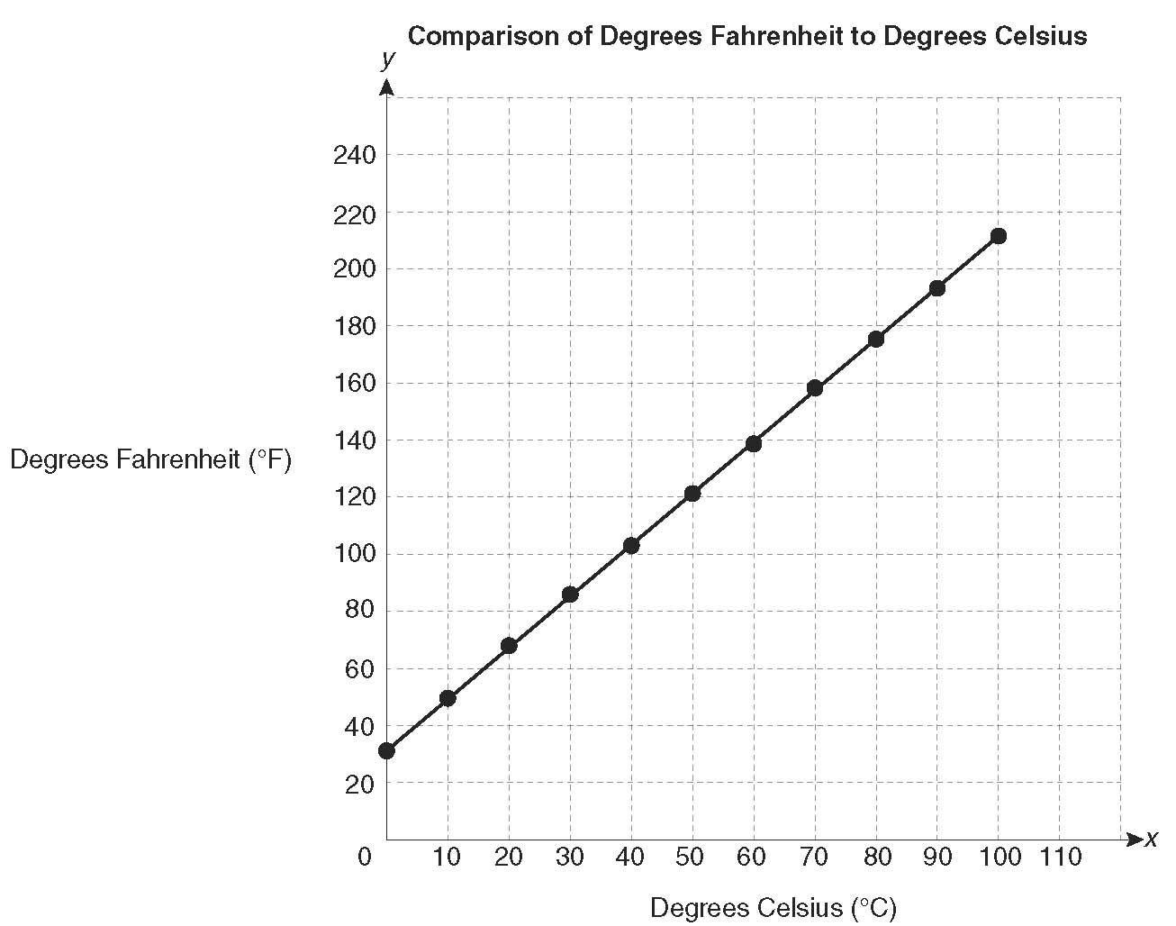

**/1** a. Given, that 1°C is 33.8°F (or ) and *d* = 1.8, write out the general formula, , that

represents the relationship between degrees Fahrenheit and degrees Celsius. Be sure to define

the variables.  
  
Answer:

**/2** b. Given two points on the graph, the freezing point of water at 0°C or 32°F and the boiling

point of water at 100°C or 212°F, calculate the slope of the line. Explain how this value

relates to the general formula found in part a.  
  
Answer:

**/2** c. Looking at the graph, what is the *y-*intercept? Explain how this value relates to the general

formula found in part a.  
  
Answer:

1. In preparing for a marathon run in the spring, Joelle runs 5 miles in week four of training and   
   10 miles in week 14. Joelle’s weekly increase in mileage follows an arithmetic sequence.

**/2** a. Write the general term that relates the number of miles to the week number of training.

Answer:

**/1** b. An official marathon is 26 miles long. In which week would Joelle run at least 26 miles?

**/2** c. What assumption is made in order to answer part b.? What are some reasons why this may not

be a good assumption?

**/16**

You have completed *Lesson 1.1 Explore Your Understanding Assignment*. Please continue your exploration with *Lesson 1.2.*