**Practice Assessment**

*Practice* provides practice and allows you to self-reflect on your conceptual understanding of the *Lesson* skills. You will mark your work for *Practice* in each Workbook according to the following rubric.

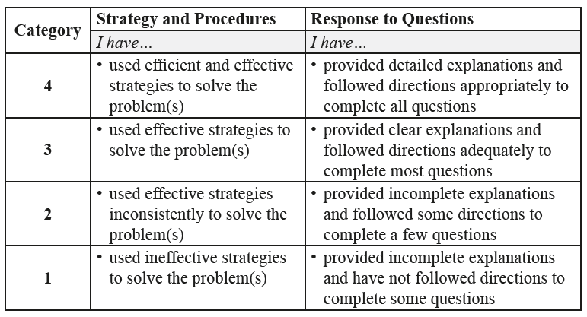

Complete *Practice* exercises using your best work, showing all relevant steps needed to arrive at your solution. Refer to the *Module* to review lesson instructions. Contact your teacher for assistance

or clarification as needed, or to investigate the topic further.

Check and correct your work using the solutions provided by the answer key.

*Practice* is worth 8 marks; your mark can help you gauge your understanding of *Lesson* material.

After you have assessed your work, reflect on your understanding of the concepts addressed in the *Practice* exercises in the table provided.

NAME:

Self-assessed mark: /8

**Lesson 1.2: Arithmetic Series**

Complete the *Practice* below. When you have completed all the questions for *Lesson 1.2 Practice – IV* with your best work, mark your work by first comparing your answers to the solutions provided by the answer key. Then, apply the rubric found at the beginning of the *Practice*.



1. The sum of the first four terms of an arithmetic series is 122 and the sum of the first nine terms of the same series is 612.
   1. Determine the common difference, *d*, of the series.  
        
      Answer:
   2. Determine the first term, , of the series.  
        
      Answer:
2. Jillian is a research assistant looking at the environmental and genetic factors related to a particular illness. Over the next two months, she will be reviewing patient files as background for further research. On the first day, she plans to review 8 patient files. On the second day, she plans to review 10, and on the third day, she plans to review 12. Over the two months, Jillian plans to work 40 days.  
   1. Determine the number of patient files Jillian should be able to review on the 40th day.  
        
      Answer:
   2. Determine the total number of patient files Jillian will review in 40 days.  
        
      Answer:
   3. What is assumed in order to answer part a. and part b.?  
        
      Answer:

Mark your work for *Lesson 1.2 Practice – IV* using the solutions provided in the *Unit* *Resources* Folder at the bottom of the online *Table of Contents* for this *Unit*. Then, apply the rubric found at the beginning of the *Practice*.

Transfer your self-assessed mark to the beginning of the *Practice*.

Reflect on your understanding of the concepts addressed in the *Practice* exercises in the table provided.

|  |  |  |  |  |
| --- | --- | --- | --- | --- |
| Question Number | Got it! | Almost there… | Need to retry or ask for help. | Similar questions from  *Pre-Calculus 11* |
| 1 |  |  |  | p.28 #10 |
| 2 |  |  |  | p.28 #9, 16, 19, 23 |

You may proceed to *Explore Your Understanding Assignment*.

**Note:** Before you complete *Explore Your Understanding*, you may review your skills and get more practice by completing the following problems in *Pre-Calculus 11*.

* Page 27 #1ad, 2bd, 3bd, 4bc, 5b, 7a, 9, 10, 16, 19, 21, and 23

Check your work in the *Resource Files* section at the end of the *Unit* of the online course.