**Practice Assessment**

*Practice* provides practice and allows you to self-reflect on your conceptual understanding of the *Lesson* skills. You will mark your work for *Practice* in each Workbook according to the following rubric.

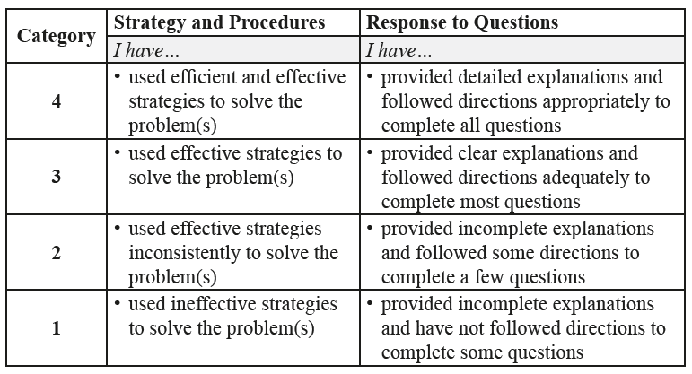

Complete *Practice* exercises using your best work, showing all relevant steps needed to arrive at your solution. Refer to the *Module* to review lesson instructions. Contact your teacher for assistance

or clarification as needed, or to investigate the topic further.

Check and correct your work using the solutions provided by the answer key.

*Practice* is worth 8 marks; your mark can help you gauge your understanding of *Lesson* material.

After you have assessed your work, reflect on your understanding of the concepts addressed in the *Practice* exercises in the table provided.

NAME:

Self-assessed mark: /8

**Lesson 1.3: Geometric Sequences**

Complete the *Practice* below. When you have completed all the questions for *Lesson 1.3 Practice – VI* with your best work, mark your work by first comparing your answers to the solutions provided by the answer key. Then, apply the rubric found at the beginning of the *Practice*.



1. Determine the number of terms, *n*, in the geometric sequence .  
     
   Answer:
2. A flower shop promises that their flowers will last for one week, and offers a money-back guarantee. In reality, the flowers lose 2% of their vibrancy each day.  
   1. What percent of the original colour do the flowers have at the end of one week (7 days)? Note the flowers will have 100% vibrancy on the first day.  
        
      Answer:
   2. How many days will have passed when the vibrancy of the flowers is 75%?  
        
      Answer:

* 1. What assumption is made in order to answer part b.?  
       
     Answer:

Mark your work for *Lesson 1.3 Practice – VI* using the solutions provided in the *Unit* *Resources* Folder at the bottom of the online *Table of Contents* for this *Unit.* Then, apply the rubric found at the beginning of the *Practice*.

Transfer your self-assessed mark to the beginning of the *Practice*.

Reflect on your understanding of the concepts addressed in the *Practice* exercises in the table provided.

|  |  |  |  |  |
| --- | --- | --- | --- | --- |
| Question Number | Got it! | Almost there… | Need to retry or ask for help. | Similar questions from  *Pre-Calculus 11* |
| 1 |  |  |  | p.40 #9d, 10e, 19b |
| 2 |  |  |  | p.40 #9, 10, 14, 19, 20 |

You may proceed to *Explore Your Understanding Assignment*.

**Note:** Before you complete *Explore Your Understanding*, you may review your skills and get more practice by completing the following problems in *Pre-Calculus 11*.

* Page 39, #1, 2c, 5, 9, 10, 14, 19, and 20

Check your work in the *Unit Resources* folder at the end of the *Unit* of the online course.