**Practice Assessment**

*Practice* provides practice and allows you to self-reflect on your conceptual understanding of the *Lesson* skills. You will mark your work for *Practice* in each Workbook according to the following rubric.

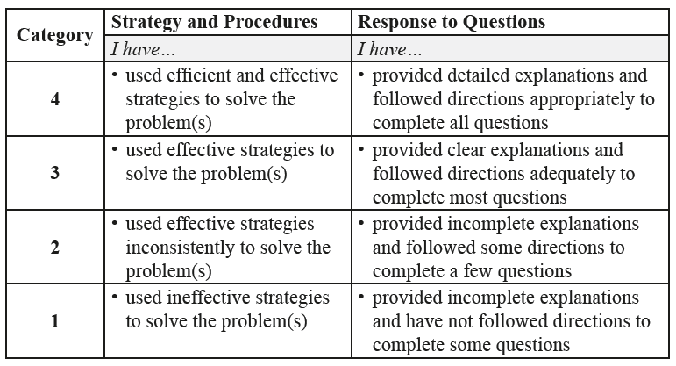

Complete *Practice* exercises using your best work, showing all relevant steps needed to arrive at your solution. Refer to the *Module* to review lesson instructions. Contact your teacher for assistance

or clarification as needed, or to investigate the topic further.

Check and correct your work using the solutions provided by the answer key.

*Practice* is worth 8 marks; your mark can help you gauge your understanding of *Lesson* material.

After you have assessed your work, reflect on your understanding of the concepts addressed in the *Practice* exercises in the table provided.

NAME:

Self-assessed mark: /8

**Lesson 1.4: Geometric Series**

Complete the *Practice* below. When you have completed all the questions for *Lesson 1.4 Practice – VIII* with your best work, mark your work by first comparing your answers to the solutions provided by the answer key. Then, apply the rubric found at the beginning of the *Practice*.



1. Determine if the following geometric series are convergent or divergent. Calculate the sum, where possible.
   1.   
        
      Answer:
   2.   
        
      Answer:
2. Andrea has rented a post pounder over the long weekend in order to put in the upright posts for her new fence. She noticed that on the first hit, the post moved 25 cm on the second hit, the post moved 10 cm. Assume the distance the post moves after each hit follows a geometric series.  
   1. In total, how far has the post moved after the third hit?  
        
      Answer:

* 1. If given an infinite number of hits, how far down would the post have moved?  
       
     Answer:

Mark your work for *Lesson 1.4 Practice – VIII* using the solutions provided in the *Unit* *Resources* Folder at the bottom of the online *Table of Contents* for this *Unit.* Then, apply the rubric found at the beginning of the *Practice*.

Transfer your self-assessed mark to the beginning of the *Practice*.

Reflect on your understanding of the concepts addressed in the *Practice* exercises in the table provided.

|  |  |  |  |  |
| --- | --- | --- | --- | --- |
| Question Number | Got it! | Almost there… | Need to retry or ask for help. | Similar questions from  *Pre-Calculus 11* |
| 1 |  |  |  | p.63 #1, 2, 6, 17 |
| 2 |  |  |  | p.63 #8, 15, 16 |

You may proceed to *Explore Your Understanding Assignment*.

**Note:** Before you complete *Explore Your Understanding*, you may review your skills and get more practice by completing the following problems in *Pre-Calculus 11*.

* Page 53 #1, 2ab, 3bd, 4ac, 5a, 6, 8, 10, 13, 22
* Page 63 #1, 2, 6, 8, 15, 16, 17

Check your work in the *Resource Files* section at the end of the *Unit* of the online course.