NAME:

**Unit 1: Sequences and Series Final Review Assignment**



This assignment includes multiple choice and short answer questions. For multiple choice questions, select the best answer. Each is worth 1 mark. Marks assigned to short answer questions are indicated for each question. Be sure to show all necessary work.

**/3** 1. Label the following sequences as arithmetic (A), geometric (G), or neither (N).

1.  ____
2.  ____
3.  ____
4.  ____
5.  ____
6.  ____

**/1**____2. Determine the number of terms, *n*, and the sum, *Sn* , of the following series.



A. 

B. 

C. 

D. 

Answer:

**/1**____3. Determine the value of  for an arithmetic sequence, where  and .

A. 

B. 

C. 

D. 

Answer:

**/1___** 4. Determine  of a geometric sequence, where  and .

A. 320

B. 640

C. 31 250

D. 156 250

Answer:

**/1___** 5. The sum of a geometric series is 126. The first term and the common ratio are both 2.  
 How many terms are in the series?

A. 5

B. 6

C. 7

D. 8

Answer:

6. Ahmed worked all summer for a bee farmer. Ahmed was paid $400.00 the first week. The

farmer paid a $50.00 raise per week for each additional week of employment. Ahmed

worked on the bee farm for 8 weeks before his first year of university began.

**/2** a. Write out the first three weeks of earnings. Is this an arithmetic or geometric sequence?

Justify.

Answer:

**/1** b. Calculate how much Ahmed earned over the 8 weeks of summer.

Answer:

**/2** c. The money Ahmed earned over the summer was used for miscellaneous expenses at

university. At the start of the ninth week of school he had $3 000.00 in his bank account.

Assuming the amount he is spending follows and arithmetic sequence, how much money

did Ahmed spend each week?

Answer:

**/2** d. The school year is approximately 32 weeks long. Will Ahmed have enough money if he

continues to spend his savings by the same amount each week?

Answer:

**/1** e. What is one assumption made in order to answer part d.?

Answer:

7. A famous fractal called the Sierpinski Triangle starts with one black triangle. The triangle is

then cut into four equal pieces, and the three outer triangles are coloured black and the inner

triangle is white. Each of the three black triangles is again divided into four equal triangles,

and the three outer triangles are shaded black.

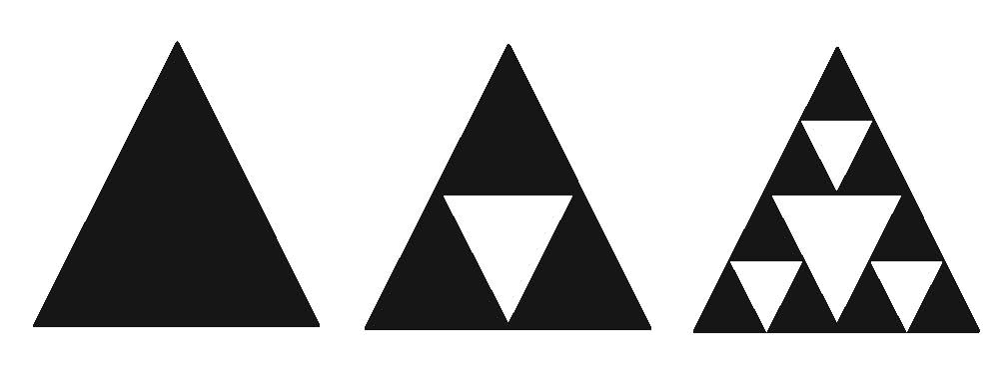

**/1** a. Suppose the area of the first triangle is 100 cm2. Determine the black shaded area in the

second triangle. Do the same for the third triangle.

Answer:

**/1** b. Write the general term describing the shaded area of the *n*th Sierpinski Triangle.

Answer:

**/2** c. Suppose the diagram continued on. What total area would be shaded in the first ten

Sierpinski Triangles? Round to the nearest whole number.

Answer:

**/2** d. Suppose the fractal continued forever. Determine the total area shaded in all the triangles,

if possible.

Answer:

**/21**