NAME:

**Lesson 2.1: Quadratic Functions Expressed in Vertex Form**



This assignment includes multiple choice and short answer questions. For multiple choice questions, select the best answer. Each is worth 1 mark. Marks assigned to short answer questions are indicated for each question. Be sure to show all necessary work.

*Use the following graph of a quadratic function to answer questions 1 and 2.*

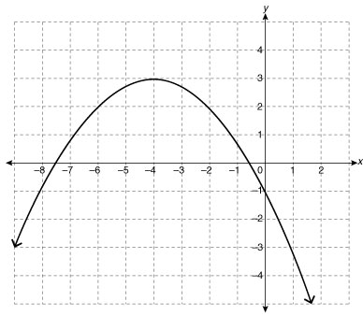

**/1** 1. The values of *p* and *q* are

1. *p* = 4; *q* = 3
2. *p* = 4; *q* = –3
3. *p* = –4; *q* = 3
4. *p* = –4; *q* = –3

Answer:

**/1** 2. Which statement best describes the range of the function?

1.  because 
2.  because 
3.  because 
4.  because 

Answer:

*Use the following quadratic function to answer questions 3 to 6.*



**/1** 3. Choose the correct statement with regards to *x*-intercepts.

1. The graph of the function has zero *x*-intercepts because *a* and *q* are both positive.
2. The graph of the function has zero *x*-intercepts because *a* and *p* are both positive.
3. The graph of the function has two *x*-intercepts because *a* and *q* are both positive.
4. The graph of the function has two *x*-intercepts because *a* and *p* are both positive.

Answer:

**/1** 4. The vertex of the function has coordinates of

1. (–4, –2)
2. (–4, 2)
3. (4, –2)
4. (4, 2)

Answer:

**/1** 5. The axis of symmetry is the line

1. *x* = –4
2. *x* = 4
3. *y* = –2
4. *y* = 2

Answer:

**/1** 6. Which statement correctly provides the direction of opening and the maximum/minimum   
 value of the function?

1. The graph of *f*(*x*) opens downward and has a maximum value of 2.
2. The graph of *f*(*x*) opens downward and has a minimum value of 2.
3. The graph of *f*(*x*) opens upward and has a minimum value of 2.
4. The graph of *f*(*x*) opens upward and has a maximum value of 2.

Answer:

*Use the following graph of a quadratic function to answer question 7.*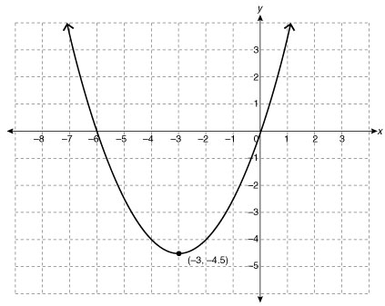

**/1** 7. What is the equation of the quadratic function in vertex form?

1. 
2. 
3. 
4. 

Answer:

**/1** 8. Describe the transformations required to change the graph of into the graph of

.

1. Stretch the graph of the function by a factor of –2, and then translate the graph 3 units to the left and 1 unit up.
2. Stretch the graph of the function by a factor of –2, and then translate the graph 3 units to the right and 1 unit up.
3. Translate the graph of the function 3 units to the left and 1 unit up, and then stretch the graph by a factor of –2.
4. Translate the graph of the function 3 units to the right and 1 unit up, and then stretch the graph by a factor of –2.

Answer:

**/3** 9. Sketch the graph of . Be sure to label the axes and at least 5 points,

including the vertex, *x*-intercept(s), and *y*-intercept, if applicable.

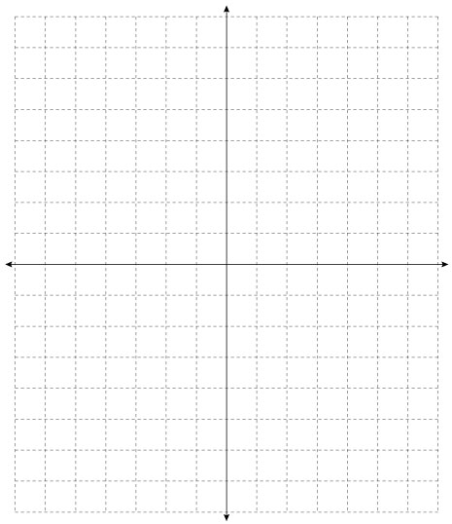

1. Adrianne is playing soccer, and kicks the ball at the goal. The ball follows the path of a quadratic function. When she kicks the ball, she is 20 ft away from the goal, and the ball hits a maximum height of 10 ft when it is 5 ft away from the goal line. If the net is 8 ft tall, does she make a goal (assuming the goalie does not stop the ball)?

**/1** a.Draw a diagram of the situation, including known values.

Answer:

**/2** b.Determine the quadratic function that models the situation.

Answer:

**/1** c.Given the information, determine whether Adrianne makes a goal.

Answer:

**/15**

You have completed *Lesson 2.1 Explore Your Understanding Assignment*. Please continue your exploration with *Lesson 2.2.*