**Practice Assessment**

*Practice* provides practice and allows you to self-reflect on your conceptual understanding of the *Lesson* skills. You will mark your work for *Practice* in each Workbook according to the following rubric.

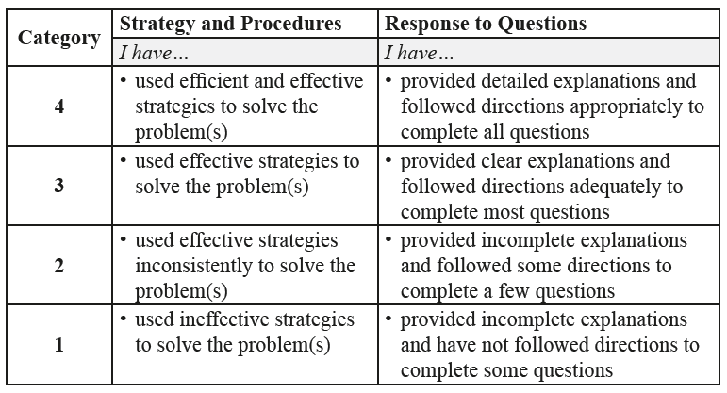

Complete *Practice* exercises using your best work, showing all relevant steps needed to arrive at your solution. Refer to the *Module* to review lesson instructions. Contact your teacher for assistance or clarification as needed, or to investigate the topic further.

Check and correct your work using the solutions provided by the answer key.

*Practice* is worth 8 marks; your mark can help you gauge your understanding of *Lesson* material.

After you have assessed your work, reflect on your understanding of the concepts addressed in the *Practice* exercises in the table provided.

NAME:

Self-assessed mark: /8

**Lesson 2.4: Quadratic Equations**

Complete the *Practice* below. When you have completed all the questions for *Lesson 2.4 Practice – VI* with your best work, mark your work by first comparing your answers to the solutions provided by the answer key. Then, apply the rubric found at the beginning of the *Practice*.



1. Solve each equation by graphing the corresponding function.
   1.   
        
        
      Answer:
   2.   
        
        
      Answer:
   3.   
        
        
      Answer:
2. Solve each equation by factoring.
   1.   
        
      Answer:
   2.   
        
      Answer:
   3.   
        
      Answer:
3. Solve each equation using square roots. Leave your answers as exact values.
   1.   
        
      Answer:
   2.   
        
      Answer:
   3.   
        
      Answer:

Mark your work for *Lesson 2.4 Practice – VI* using the solutions provided in the *Unit* *Resources* Folder at the bottom of the online *Table of Contents* for this *Unit.* Then, apply the rubric found at the beginning of the *Practice*.

Transfer your self-assessed mark to the beginning of the *Practice*.

Reflect on your understanding of the concepts addressed in the *Practice* exercises in the table provided.

|  |  |  |  |  |
| --- | --- | --- | --- | --- |
| Question Number | Got it! | Almost there… | Need to retry or ask for help. | Similar questions from  *Pre-Calculus 11* |
| 1 |  |  |  | p.125 #3, 4 |
| 2 |  |  |  | p.230 #7ace, 8bdf, 9ace, 10bdf |
| 3 |  |  |  | p.240 #4c, 5ace, 6bdf, 7ace |

Please return to *Lesson 2.4* to continue your work in *Unit 2: Quadratic Functions and Equations*.