NAME:

**Lesson 2.4: Quadratic Equations**



This assignment includes multiple choice and short answer questions. For multiple choice questions, select the best answer. Each is worth 1 mark. Marks assigned to short answer questions are indicated for each question. Be sure to show all necessary work.

**/1** 1. The roots of the equation  are



1.  and 
2.  and 
3.  and 
4. 3 and 7

Answer:

**/1** 2. One of the roots of the quadratic equation  is

1. 
2. 
3. 
4. 

Answer:

**/1** 3. The exact root(s) of  is/are

1. 
2. 
3. 
4. 

Answer:

4. On the reality TV show *Last Man Standing,* a package is thrown from a plane to the ocean below. The contestants must swim to the package to receive the “free pass” located inside the package. The path that the package follows can be modelled by the quadratic function , where *d* represents the distance above the water, in metres, and *t* is the time, in seconds.

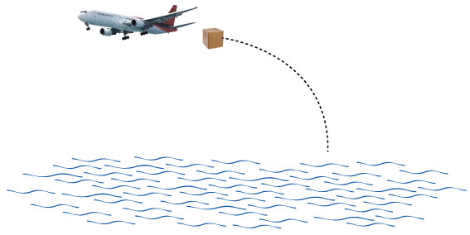

**/2** How long has the package been in the air when it hits the water?  
  
Answer:

**/3** 5.Lacy has $600.00 set aside to build a rectangular exercise kennel for her dogs. She will buy   
 fencing material for $15/ft. Because the side of an existing barn will be used for one of the sides   
 of the kennel, only three sides need to be fenced. Lacy needs the area of the kennel to be 150 ft2.   
 Determine the dimensions of a kennel that uses all possible fencing material.

**/8**

You have completed *Lesson 2.4 Explore Your Understanding Assignment*. Please proceed to the *Unit 2: Quadratic Functions and Equations Final Review Assignment.*