NAME:

**Lesson 4.1: Angles in Standard Position**



This assignment includes multiple choice and short answer questions. For multiple choice questions, select the best answer. Each is worth 1 mark. Marks assigned to short answer questions are indicated for each question. Be sure to show all necessary work.

Without measuring, match the angle in standard position with the sketch.

**/1** 1. 175°

**/1** 2 25°

**/1** 3. 75°

**/1** 4. 225°

**/1** 5. 275°

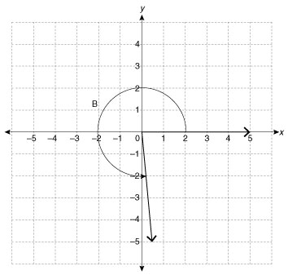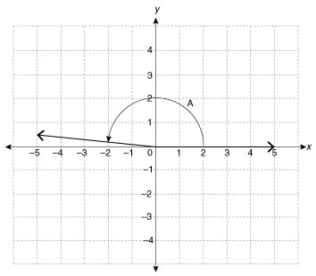A. B.

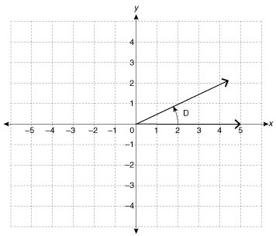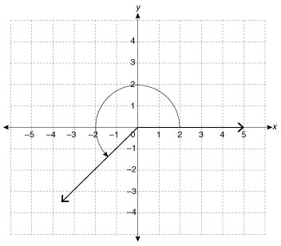

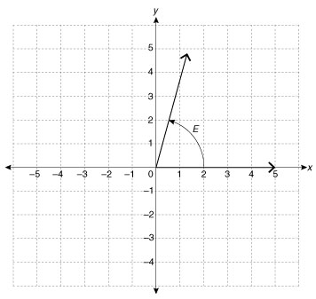C. D.

E.

**/1** 6. The reference angle of 188° is

1. 8°
2. 12°
3. 98°
4. 188°

Answer:

**/1** 7. The angle in standard position that does **not** have a reference angle of 15° is

1. 165°
2. 195°
3. 255°
4. 345°

Answer:

**/2** 8. The point (–2, 4) is on the terminal arm of an angle in standard position. Sketch the angle,

along with three other angles in standard position with the same reference angle.

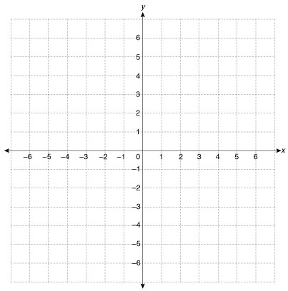

**/2** 9. For the construction of a deck surrounding a bay window, Tricia must cut several boards at

an angle of 120°. Setting up her mitre saw, she sets and angle of 30°. Will this cut the wood

at the correct angle? If not, what angle should she use if her mitre saw can only be moved up

to 90°.  
  
 Answer:

**/11**

You have completed *Lesson 4.1 Explore Your Understanding Assignment*. Please continue your exploration with *Lesson 4.2.*