NAME:

**Lesson 4.3: Solving Non-Right Triangles**



This assignment includes multiple choice and short answer questions. For multiple choice questions, select the best answer. Each is worth 1 mark. Marks assigned to short answer questions are indicated for each question. Be sure to show all necessary work.

**/1** 1. Determine the unknown side length, *x*, of the following triangle.  
  
 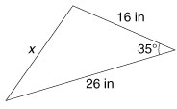

1. 15.8 in
2. 17.4 in
3. 21.3 in
4. 52.0 in

Answer:

**/1** 2. Determine the unknown angle measure, *x*.  
  
 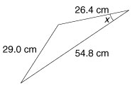

1. 8.1°
2. 8.8°
3. 24.4°
4. 163.1°

Answer:

**/1** 3. Determine the unknown side length, *x*, of the following triangle.

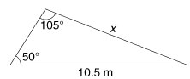

A. 4.6 m

B. 5.8 m

C. 8.3 m

D. 13.2 m  
  
Answer:

**/1** 4. Determine the unknown angle measure, *x*.

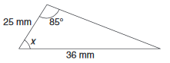

1. 41°
2. 44°
3. 46°
4. 51°

Answer:

**/1** 5. Triangle *ABC* has the following dimensions: ∠*A* = 17°, *a* = 37 in, *b* = 91 in. The number of

triangles possible with these dimensions is (are)

1. One oblique triangle
2. One right triangle
3. Two triangles
4. No triangles

Answer:

**/2** 6. When touring Italy, Raphael visits the Leaning Tower of Pisa. From the base of the short side

of the tower, Raphael walks 137 m, and measures the distance to the top of the short side of

the tower to be 142 m, with an angle of elevation of 23°. Determine the height of the short

side of the Leaning Tower of Pisa. Round to the nearest metre.

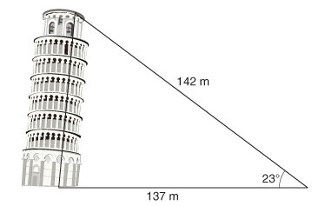

7. Patricia and Trent are 48 m apart. The angle of elevation from Patricia to the hot air balloon

hovering in the sky between her and Trent is 43°, while the angle of elevation from Trent to

the balloon is 31°.

**/1** a. Draw a diagram of the situation.

**/2** b. Determine the distance between the balloon and the person farthest from the balloon.

Round to the nearest tenth of a metre.

**/10**

You have completed *Lesson 4.3 Explore Your Understanding Assignment*. Please proceed to the

*Unit 4: Trigonometry Final Review Assignment.*