NAME:

**Unit 4: Trigonometry**



This assignment includes multiple choice and short answer questions. For multiple choice questions, select the best answer. Each is worth 1 mark. Marks assigned to short answer questions are indicated for each question. Be sure to show all necessary work.

**/1**____1. What is the reference angle for 220° in standard position?

A. 40°

B. 50°

C. 140°

D. 220°

Answer:

**/1**____2. Which of the following angles does **not** have a reference angle of 10°?

A. 10°

B. 80°

C. 170°

D. 190°

Answer:

**/1___** 3. The point is on the terminal arm of θ, an angle in standard position. Which primary

trigonometric ratio is correct?

A. 

B. 

C. 

D. 

Answer:

**/1___** 4. What is the exact value of tan 240°?

A. 

B. 

C. 

D. 

Answer:

**/1___** 5. An angle is in standard position, such that . What are the possible values of *θ*, to

the nearest degree, if .

A. 46° and 134°

B. 46° and 226°

C. 134° and 314°

D. 226° and 314°

Answer:

**/1___** 6. Determine the length of side *x*. Round to the nearest tenth of a metre.

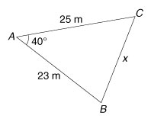

A. 16.5 m

B. 20.2 m

C. 28.0 m

D. 31.3 m

Answer:

**/1___** 7. Determine the measure of angle *θ*. Round to the nearest tenth of a degree.

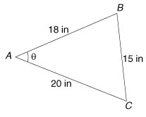

A. 11.6°

B. 43.9°

C. 46.1°

D. 59.9°

Answer:

**/1___** 8. Determine the length of side *x*. Round to the nearest tenth of a centimetre.

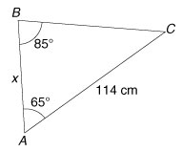

A. 57.2 cm

B. 62.9 cm

C. 103.7 cm

D. 125.3 cm

Answer:

**/1___** 9. To solve for *x* in the triangle below, which strategy would be **best**?

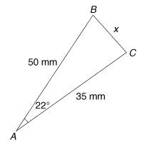

A. The cosine law

B. The sine law

C. The primary trigonometric ratios

D. Either the cosine law or the sine law.

Answer:

10. In ∆*ABC*, *c* = 10 cm, *b* = 8 cm, and ∠*B* = 35°.

**/1** a. Sketch a diagram of the two possible triangles.

Answer:

**/3** b. Solve the triangles.

Answer:

**/3** 11. A rescue helicopter locates two people caught in an avalanche. The angle of elevation from

the first person to the helicopter is 26.7°, and the angle of elevation from the second person

to the helicopter is 48.9°. If the distance between the two people is 165 m, determine how far

both people are from the helicopter. Round to the nearest metre.   
  
 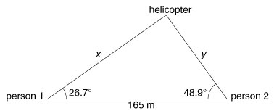  
  
 Answer:

**/2** 12. A drive belt wraps around three pulleys, *D*, *E*, and *F*. The distance between pulleys *D* and *E*

is 5 cm, the distance between pulleys *E* and *F* is 7 cm, and the distance between pulleys *D*

and *F* is 10 cm. Determine the angle of the belt at pulley *E*. Round to the nearest tenth of a

degree.  
   
 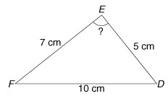  
  
 Answer:

**/18**