NAME:

**Lesson 5.2: Operations on Rational Expressions**



This assignment includes multiple choice and short answer questions. For multiple choice questions, select the best answer. Each is worth 1 mark. Marks assigned to short answer questions are indicated for each question. Be sure to show all necessary work.

**/1** 1. Which rational expression simplifies to ?

1. 
2. 
3. 
4. 

Answer:

**/1** 2. The simplified rational expression of  is

1. 
2. 
3. 
4. 

Answer:

**/3** 3. Simplify the expression . Indicate any non-permissible  
 values.

Answer:

**/4** 4. Adding, subtracting, multiplying, and dividing rational expressions are similar to performing

the same operations on rational numbers. Using examples for each operation, support this

statement.

Answer:

**/3** 5. Jules is training for a marathon. She finds that for the first 5 km of her training run, she runs

at a constant speed of *x* km/h. For the remaining 7 km of her training run, her speed reduces

by 5 km/h. Write an algebraic expression for the total time Jules takes to run 12 km. Recall

that .

.

Answer:

**/2** 6. Write a simplified expression, in terms of *c*, for the area of the given triangle.  
  
 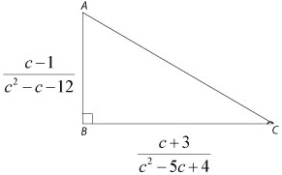

Answer:

**/14**

You have completed *Lesson 5.2 Explore Your Understanding Assignment*. Please continue your exploration with *Lesson 5.3.*